**University of Mary Division of Education**

**Lesson Plan Format**

**Grade Level:**

Tenth through Twelfth Grade

**Subject(s) Area:**

Algebra II period: 1 or A

**Materials Needed:**

* For students:

Each student needs their notebook, guided notes to put in their notes, calculator (optional), a pencil, and colored pens (blue and red).

* For me, the teacher:

I need to have a computer, active board that hooks up to the laptop, PowerPoint for lecture slides, pens for active board, guided notes for the class (*attached to end of document*), extra calculators, glue sticks and bottle, staples, tape, a whiteboard with markers, and worksheet for homework for the students (*attached to end of document*).

**Standards:**

The standards for this lesson are based on the Common Core standards:

* HS.F-IF.7. Graph functions expressed symbolically and show key features of the graph, by hand in simple cases and using technology for more complicated cases.

**Objectives:**

* *Prior knowledge for this lesson is to be able to know and understand radians and degree measure, regular graphing techniques (x-axis, y-axis, and plotting points), and the domain and range of a function*.
* Students will be able to graph trigonometric functions expressed symbolically and show key features of the graph.
* Students will be able to graph simple cases by hand.
* Students will be able to recognize and recall specific terminology such as, trigonometric function, amplitude, increment, period, midline, domain, and range.
* Students will be able to graph the trigonometric function showing period, midline, and amplitude included in the graph.

**Learning Activities:**

* Students will come into class and go to their assigned seats. They can talk amongst themselves until the final bell rings at 8:20.
* I will get their attention, and I will introduce myself, just in case they have forgotten who I am. I will also explain that this class is going to be a little different since they are used to a flipped classroom.
* We will start right away with lecture and notes. I will pass out the guided notes and explain to them that they can write on their notes right now. The guided notes are for the two example problems in the PowerPoint. Once we are done working with notes, they can tape, staple, or glue their notes into their notebooks.
  + Starting with notes (I will have the smart board ready and pulled up with my PowerPoint ready to go before the students come into the classroom.)
  + First slide:

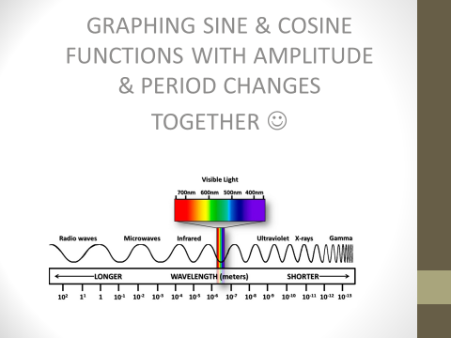

* + - This slide is just the intro slide. Yesterday Mrs. Brenden worked on graphing sine and cosine functions with them. They may have done problems where they had a period change or an amplitude change, but today we are going to be graphing these two changes together.
    - The picture is there so I can show the students how period changes are applicable to real life. Sine and cosine functions can model sound waves and other waves, and we can use these waves to compare them to other waves to find properties that we never have found before.
  + Second slide:

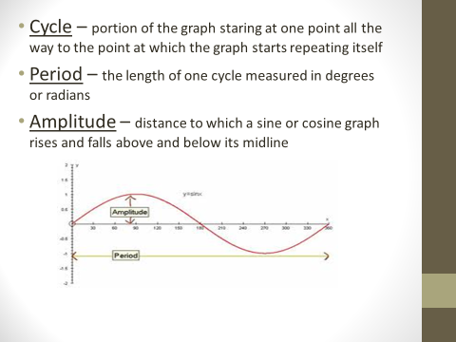

* + - This slide is review of vocabulary terms, or the characteristics of the sine graph. I want to make sure that the students know what these terms mean in terms of the interpreting the graphs we will be graphing in later slides.
  + Third slide:

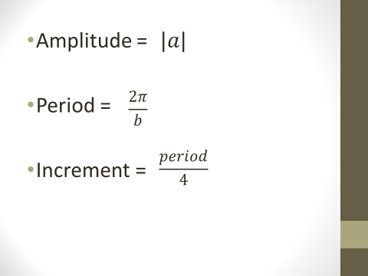

* + - This slide is also review for them. I just want the students to remember how we find these characteristics of the graph. We are also going to be finding these features of a graph in the following two slides.
  + Fourth slide:

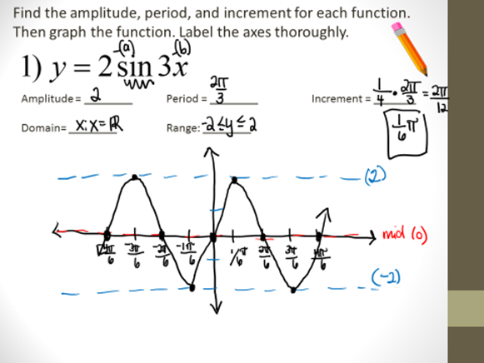

* + - This slide is the first example. This slide is an example of what I would be writing on the board.
    - I am going to go through the problem with them asking them to help me find the amplitude, period, and the increment.
    - Then I am going to ask the students to help me graph the equation we are given of sin with these new changes. I need to make they know where the midline falls and where the amplitude asymptotes fall because that will be useful information to understand later lessons in the chapter. Also, make sure students are using red pens for midline and blue pens for amplitude. That will stay consistent throughout the entire chapter.
    - Before I move onto the next slide, I am going to ask them to recall how to find the domain and range of the graph we just sketched.
  + Fifth slide:

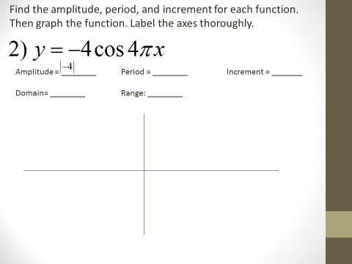

* + - This slide is the second example I am going to do with them. This slide is shows what the slide looks like before I write anything on the board.
    - Again I am going to ask for help to find the amplitude, period, and the increment.
    - Before we start graphing, I am going to ask how this equation is different from the last equation we graphed in the lasted problem. I am hoping that they will see the negative sign in front because that means that the graph will be flipped upside down, or reflected across the x-axis. The whole chapter is on transformations of trig functions, but they have already done transformations on linear functions and parabolic functions so I am hoping that they recognize this transformations.
    - Then we start graphing and I will ask them to help me in the proper steps I need to make to graph this equation.
    - Finally, I will ask them to identify the domain and range of the graph before ending the slide.
  + That is all the slides for my lecture portion.
* After notes are completed I will pass out the homework worksheet.
  + They can work on the homework in class, and I will help them if they have questions. They can work with others, but I want them to stay focused on the assignment.
  + If there are some questions that commonly being asked, I will address the whole class to re-explain to avoid confusion.
  + If there are a lot of students who have their hands up, Mrs. Brenden has agreed she will help me and answer questions as well.
  + If students finish their homework, they can work on makeup work or other homework from other classes.
* Students can work on their homework until the bell rings. When the bell rings, students know that they are dismissed and can leave the classroom.

**Assessment:**

* Students will be formally assessed at the end of the chapter with a traditional paper and pencil test.
* As a formative assessment, students will do their homework assigned and turn in the homework the following day.

**Reflection:**

Overall, I think I did pretty well. I had some mistakes, and I could have done some things differently. I did well on presenting the material in the lecture of the lesson plan, except for the fact that I forgot to find the domain and range on the first example problem. The technology, or active board, could have been better. At least three times, the active board did not recognize the pen I was using, so Mrs. Brenden had to help me with re-calibrating the screen to recognize the pen. If I would have known how bad the board would have been, I should have just wrote on the marker board. After I taught for my lesson, I gave the students a worksheet assignment, and I tried my best to refresh my memory to be prepared for all the possible questions that the students might have. However, I could not prepare myself enough. I got a question from a student about why the amplitude had to be the absolute value of a, and why the negative sign counted for the reflection across the x-axis but why the negative sign did not count for the amplitude. I knew the answer, but I did not know how to articulate it well enough in order to make sense to the students. I stumbled over my words, and only some students understood me. The girl that asked me, did not get it after my explanation, and so I revisited with her to explain it to just her when she was working on the worksheet.

**Guided Notes for students**

**Find the amplitude, period, and increment for each function. Then graph the function. Label the axes thoroughly.**



Amplitude = ________ Period = ________ Increment = _______

Domain= ________ Range: ________



Amplitude = ________ Period = ________ Increment = _______

Domain= ________ Range: ________

**Algebra II Worksheet Name ___________________________**

**Worksheet 14.1 Day 2 Period ______**

**Match the function with its graph.**

______ 1)  ______ 2)  ______ 3) 

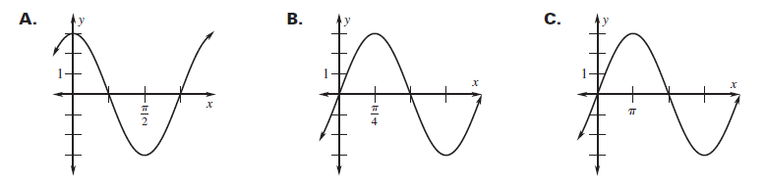

**Find the amplitude, period, and increment of each function. Then graph two periods of the function. Label the axes thoroughly.**

4) 

Amplitude = _______ Period = ________ Increment = ________

Domain= ________ Range: ________

5) 

Amplitude = _______ Period = ________ Increment = ________

Domain= ________ Range: _______

6) 

Amplitude = _______ Period = ________ Increment = ________

Domain= ________ Range: ________

7) 

Amplitude = _______ Period = ________ Increment = ________

Domain= ________ Range: ________

8) 

Amplitude = _______ Period = ________ Increment = ________

Domain= ________ Range: ________

9) 

Amplitude = _______ Period = ________ Increment = ________

Domain= ________ Range: ________

10) 

Amplitude = _______ Period = ________ Increment = ________

Domain= ________ Range: ________

11) 

Amplitude = _______ Period = _________ Increment = _________

Domain= ________ Range: ________

12) 

Amplitude = _______ Period = _________ Increment = _________

Domain= ________ Range: ________

13) 

Amplitude = _______ Period = _________ Increment = _________

Domain= ________ Range: ________

14) 

Amplitude = _______ Period = _________ Increment = _________

Domain= ________ Range: ________