University of Mary Division of Education
Lesson Plan Format

Grade Level:
Tenth through Twelfth Grade

Subject(s) Area:
Algebra II period: 1 or A

Materials Needed:
- For students:
Each student needs their notebook, guided notes that they filled out the previous night, calculator (optional), and a pencil.
- For me, the teacher:
I need to have a computer, active board that hooks up to the laptop, guided notes for the class (attached to end of document), extra calculators, chrome books for those students who forgot to watch the lesson video, glue sticks and bottle, staples, tape, a whiteboard with markers, and worksheet for homework for the students (attached to end of document).
Standards:
The standards for this lesson are based on the Common Core standards:
- HS.F-IF.8. Write a function defined by an expression in different but equivalent forms to reveal and explain different properties of the function.
Objectives:
Prior knowledge for this lesson is to be able to understand and graph the exponential model of y=a(b)^{t}. Students should know that when b>1, the model is a growth model, and when b<1 the model is a decay model.
- Students will be able to use the properties of exponents to interpret expressions for exponential functions.
- Students will be able to identify the rate of change in exponential functions in order to classify the functions as representing exponential growth or decay.
- Students will be able to apply growth and decay functions by writing models according to real world situations of growth and decay, such as population growth or depreciation of a car.
Learning Activities:
- Students will come into class and go to their assigned seats. They can talk amongst themselves until the final bell rings at 8:20.
- I will get their attention and ask for them to put their phones away. I will tell them that I am teaching today.
- Today is a flipped classroom. The students should have watched the lesson video I created the previous day or night. (The URL link to watch my video lesson is: https://www.youtube.com/watch?v=IHYX2FtlM6o. I have attached my finished slides from the video at the end of this document as well.)
The students should have taken notes in their notebooks or on the guided notes.
  - If students did not watch their video. They can use their smart phones, or the school chrome books to watch the video. They should take notes while watching the video. I can give them an extra guided note packet if they want to take notes on those. Students are allowed to watch the video in the hall if they are getting distracted in the classroom.
  - If the students have watch their video they can get started on worksheet assignment. I will pass out the worksheet to the students who have watched the video. I will know if students watched the video by checking their notes.
  - They can help each other work on the worksheet. They can only work with others if they stay focused on the assignment. I will help them if they have questions. It is a room procedure that they cannot ask me until they re-read the question, have referenced their notes, have referenced the video again, and have asked a friend. I should be the last resource they need to ask.
  - If there are some questions that commonly being asked, I will address the whole class to re-explain the questions on the board.
  - If there are a lot of students who have their hands up, Mrs. Brenden has agreed she will help me and answer questions, so students are not waiting a long time to get help.
  - If students finish their homework, they should first watch the video for the next day of class. If they finish that video, then they can work on other homework from other classes.
- Some students may have been gone the previous day. If that is the case, they should work on the video and homework from the day they missed before working on this lesson video and worksheet.
- When the bell rings, students know that they are dismissed and can leave the classroom.
Assessment:
- Students will be formally assessed at the end of the chapter with a traditional paper and pencil test.
- As a formative assessment, students will do their homework assigned and turn in the homework the following day.
Reflection:
Today went very well. The students are used to a flipped classroom, so they just did their daily routine. First period complained very much about the length of the worksheet, so I told them that they did not have to do certain problems. The problems I took off were similar to other problems on the previous parts of the worksheet. It was hard for me to remember that I could not help the students until they had exhausted all their other resources. The students were very quick to give up on their own and ask, and I eventually realized that was the case because some students only watched part of the video. Once I could tell they may have not watched the entire video, I told them to reference the video and their notes again. Some students listened to me, and other students did not. Only a handful of students finished the worksheet, and everyone else was struggling to finish it. Mrs. Brenden realized that meant most did not watch it, so she stepped in and told them that they had to watch it in full before watching the next video. Nonetheless, it was fun to walk around and help the students. It was also fun to learn to get to get to know them a little better. Overall, I thought the class went well because the flipped classroom is what the students are most accustomed to.

Exponential Growth and Day Applications
Exponential Growth Models…REAL LIFE
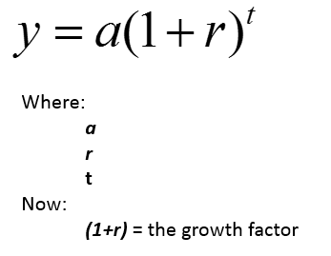
Population is an example of Exponential Growth-
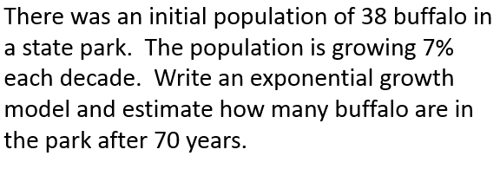

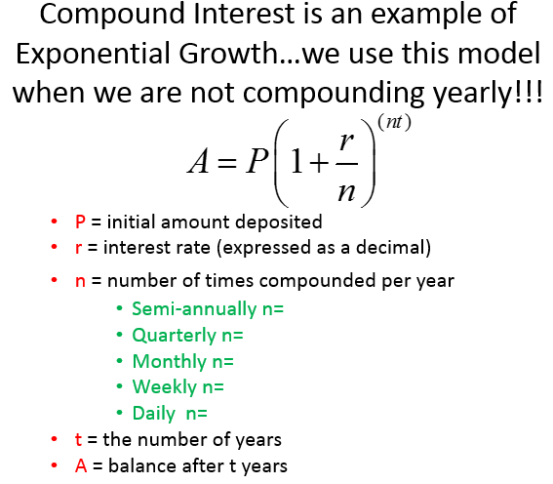
Example of Compound Interest
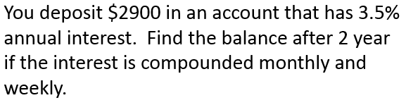

Exponential Decay Models…REAL LIFE
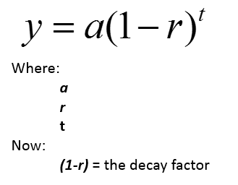
Depreciation is an example of Exponential Decay
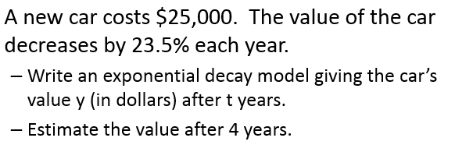
Algebra II Name____________________
Exponential Growth & Exponential Decay Worksheet

- Money Choices. Which option gives the greater ending balance?
  - Put $360 in an account that pays 5% interest compounded monthly for 10 years?

  - Put $375 in an account that pays 4.5% interest compounded monthly for 10 years?

- Money Choices. Which option gives the greater ending balance?
  - Put $100 in an account that pays 8% interest compounded quarterly for 10 years?

  - Put $175 in an account that pays 7% interest compounded quarterly for 5 years?

- Profit Increases. From 1990 to 2000, the profit earned by a company increased by about 1.5% per year. Use the graph below to write the exponential model. Then use the model to find the profit in 2000.

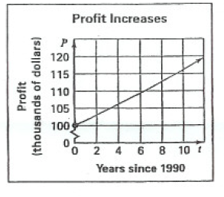

- Population. A town had a population of 48,000 in 1995. Then the population grew by 8% per year for the next 5 years. Write an exponential model for the town’s population over the 5-year period. Determine that population. Then use the model to find the population in 2020.

- California. The population increased about 32% per decade from 1930 to 1990. Use the graph below to write an exponential model. If the population continues to increase, what will the population be in 2010?
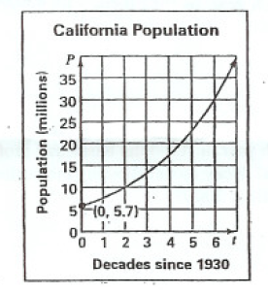

- Business Profit. A business had a $5000 profit 1990. They had a profit gain of 15% per year for the next decade. Write an exponential model for the company’s profit over the 10-year period. Determine the profit. Then use the model to find the profit in 2005.

- Memorizing Vocabulary. You memorized 15 Spanish vocabulary words. Then you memorized 20% more words each week for the next 10 weeks. Write an exponential model for the number of vocabulary words you memorized over the 70 day period and determine the amount. Use the model to find the number of vocabulary words you knew after 140 days.

- Fruit Fly Population. You begin with 50 fruit flies for a science project. The fruit flies increase in number by 30% each day for a week. Write an exponential model for the number of fruit flies over the one-week period and determine that amount. Use the model to find the number of fruit flies you have at the end of 10 days.

- Car Value. You buy a used car for $15,000. The car depreciates at the rate of 23% per year. Write the model for each of the following given years and then find the value of the car for the given year.

  - 1 year
  - 3 years
  - 5 years
  - 8 years

Classify the model as exponential growth or exponential decay.

- Population. Between 1985 and 2000, the population of a city decreased by approximately 3% each year. In 1985, there were 450,000 people. Write a model and determine the population in 2000.

- Losses. Between 1990 and 2000, the business lost approximately 0.7% each year. In 1990 the business’s profit was $1.4 million. Write an exponential model showing the business’s profits for 10 years and determine the amount. Then determine the profit in 2005?

- Unemployment Rate. In 1998 the unemployment rate of a city reduced by approximately 1.2% each month. In January the unemployment rate was 8%. Write an exponential model and determine the rate in December?

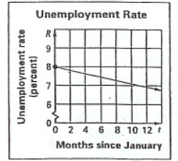

Slides from my video lesson:
