**University of Mary Division of Education**

**Lesson Plan Format**

**Grade Level:**

Tenth through Twelfth Grade

**Subject(s) Area:**

Algebra I Year 2: period 4 or D

**Materials Needed:**

* For students:

Each student needs their notebook, guided notes to glue in their notes, calculator (optional), and a pencil.

* For me, the teacher:

I need to have a computer, active board that hooks up to the laptop, pens for active board, guided notes for the class (*attached at the end of the document*), cards for the activity (*attached at the end of the document*), worksheet for homework, extra calculators, glue sticks and bottle, and a whiteboard with markers.

**Standards:**

The standards for this lesson are based on the Common Core standards:

* HS.A-APR.1. Understand that polynomials form a system analogous to the integers, namely, they are closed under the operations of addition, subtraction, and multiplication; add, subtract, and multiply polynomials.

**Objectives:**

*Prior knowledge for this lesson is to be able to recognize and understand the terms monomials, binomials, trinomials, polynomials, degree of a polynomial, and the leading coefficient*. *Student also need to know how to write polynomials in standard form.*

* Students will be able to identify like terms.
* Students will be able to add and subtract polynomials.
* Students will be able to write their answers in standard form.

**Learning Activities:**

* Students will come into class and go to their assigned seats. They can talk amongst themselves until the final bell rings at 11:02.
* I will get their attention, and I will introduce myself, just in case they have forgotten who I am. I will explain that I am teaching today’s class.
* I will explain the agenda of the three main parts of my lesson one at a time. I will start with the first review activity. The active board has a matching game software, pictured below.

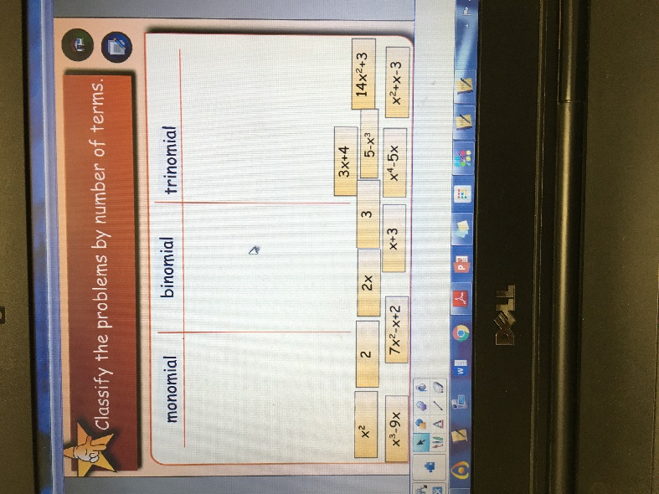 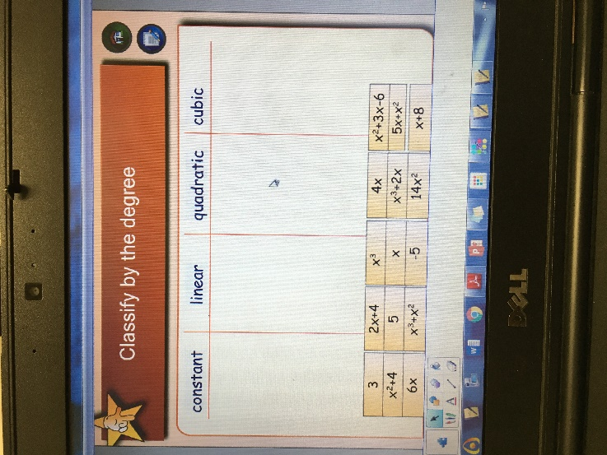

* The review activity consists of two matching games.
* We will start with the “Classify the problems by number of terms.” Students will come up to the board and drag a term into one of the three categories of monomial, binomial, and trinomial. Students will come up as I call on them. Students can help each other decide where to drag the terms. I should make sure all students go at least once. We will repeat the process for the “Classify by the degree.” This should be review for the students, since they learned this the previous day.
* After they are done with the activity, and once I have answered any questions, we will move onto the notes for adding and subtracting polynomials. I will pass out the guided notes foldable. I will explain to them that they can write on their notes right now. The guided notes correspond to the PowerPoint presentation I will lecture on the active board. Once we are done working with notes, they can tape, staple, or glue their notes into their notebooks.
* The first slide explains like terms: 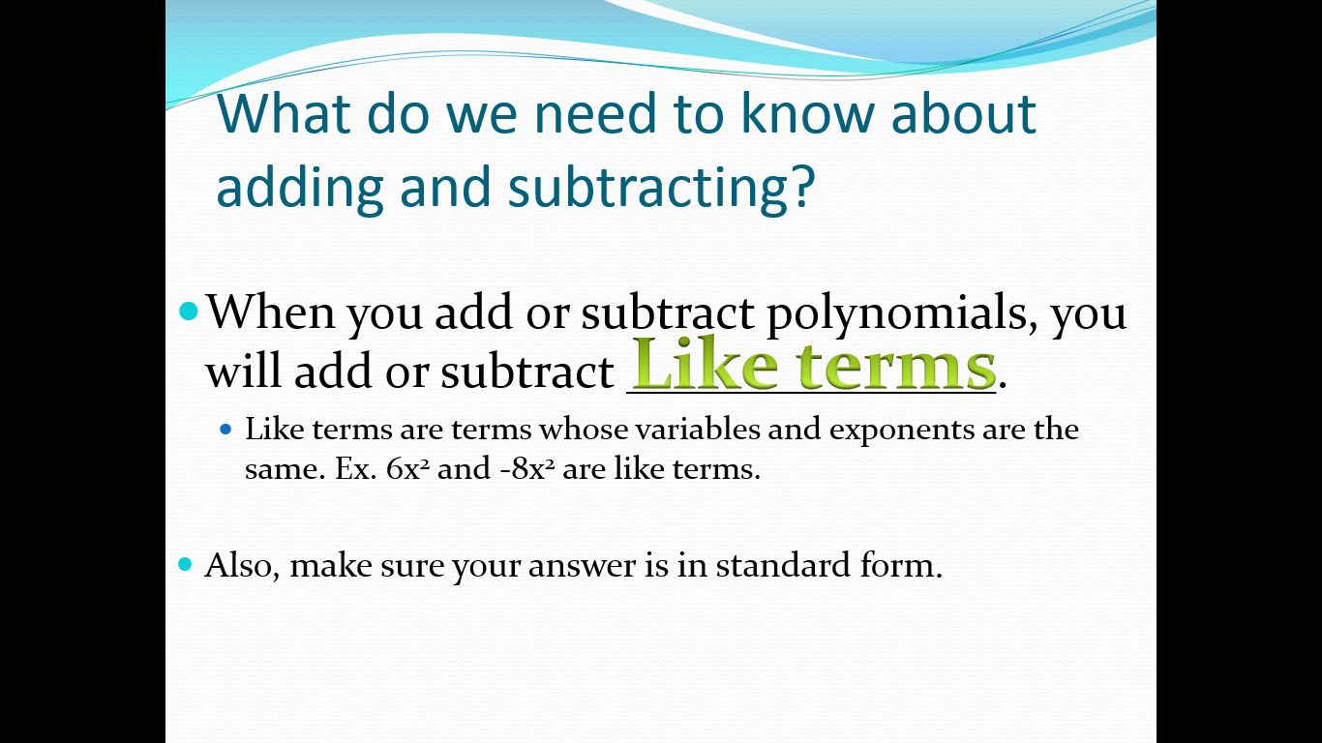
* After this first slide, we will do an activity for like terms. I will pass out one card to each student. The students have to get up and find their like terms. I hope that this will help students talk to each other so they can come to understand what like terms are.
* After everyone has their proper like terms, they can take their seats again. We will continue with notes.

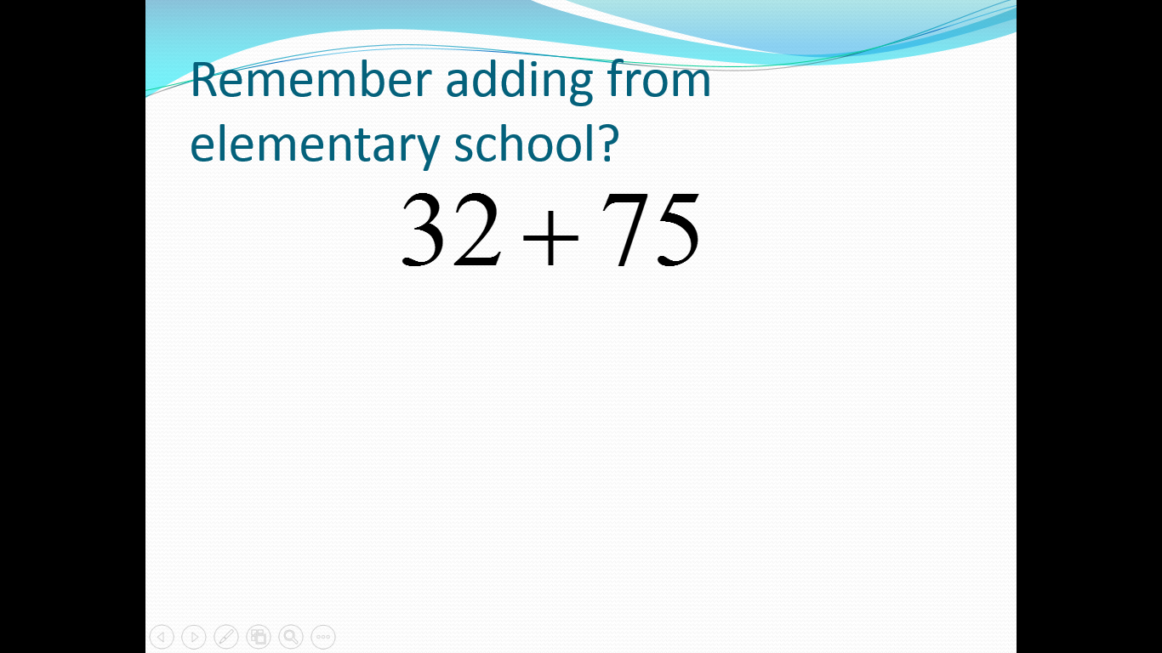

32

107

Pictured above demonstrates how I will ask them to remember how they added in elementary school, or added vertically. I will remind them that we start adding from right to left. What is typed in red, I will write on the active board.

* 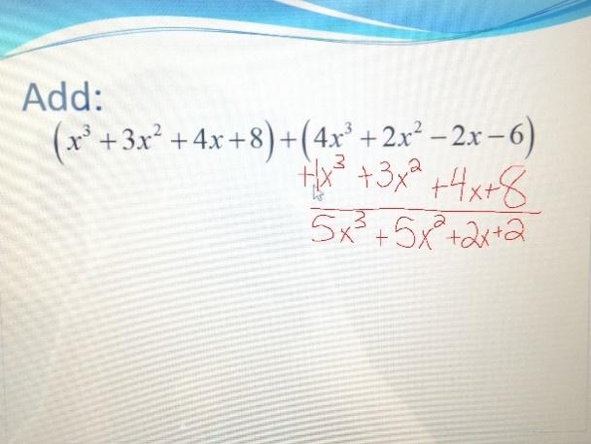We will do two examples of adding and two examples of subtracting.
* Example 1 of adding:

While I do the example, I will remind them that we need to match like terms and to add vertically. When I am done adding, I will ask them if the answer is in standard form. And they should know that it is.

* Example 2 of adding:

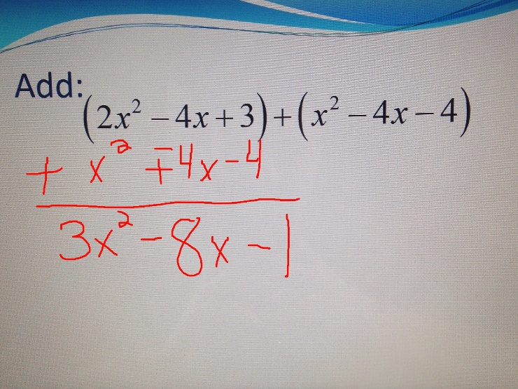I will do another example, but this time I will add under the left side to reinforce the fact that order does not matter for addition. I will make sure that the students tell me how to do the problem. I will ask them to walk me through the steps. I will make sure that they are matching like terms. When I am done, I will ask them if it is written in standard form, and they should say yes.

* 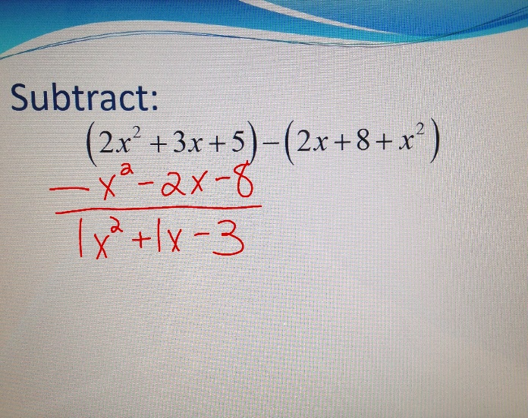Example 1 of subtracting:

For the first example of subtracting, I will have the students realize that they cannot just subtract on any side. Giving them the example that 5 – 2 is 3 and 2 – 5 is -3 and 3 and -3 are not the same number, so when we are subtracting order matters. They must subtract the right side from the left. For this example, I want the students to match like terms, and then subtract each right term from each corresponding left term. I will ask the students if the answer is in standard form, and they should answer that it is.

* 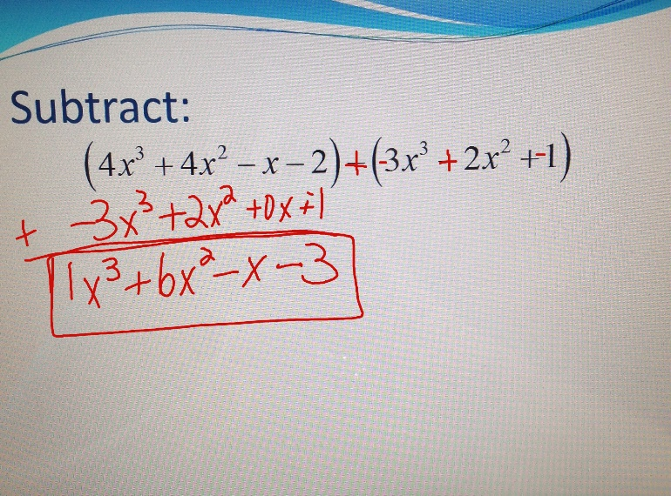Example 2 of subtracting:
* I will do final example. The only change in this example is that the negative sign can be distributed to the terms in the right set of parentheses. After the negative is distributed, they can add the new right side to the left side. Their answer should be in standard form.
* If there are no questions about the lecture, then I will hand out the worksheet as their homework. They can work on the worksheet for the rest of the period. The students can ask me questions. I will walk around to see how students are doing, and I will help the ones who seem like they are struggling.
* Students can work on their homework until the bell rings. When the bell rings, students know that they are dismissed and can leave the classroom.

**Assessment:**

* Students will be formally assessed at the end of the chapter with a traditional paper and pencil test.
* As a formative assessment, students will do their homework assigned and turn in the homework the following day.

**Reflection:**

This class, Algebra I year 2, is a math class for students who need extra assistance on math. Most of the students in the class are on IEP’s, and Mrs. Brenden has help from two other special education teachers as well. Mrs. Brenden told me that I could teach, but she would reinforce behavior if she needed to, and I definitely used her help in this lesson. For this class, I had to come up with more than one activity. The review game at the beginning of class went well for most students. It obviously did not go well for the students who had skipped the previous day, and that made the rest of the lesson harder for them. I wish I would have known that some students had missed the previous day, but that was the point of the review game. I should have reviewed the previous day’s lesson more than I had, so I could have been more help to those students. Mrs. Brenden was kind enough to get those few students caught up while I taught.

After the review game, we did another activity of pairing of like terms to help the students with knowing what like terms are. I had cards laminated, and the students were supposed to get up and find their like term partner. If I would have realized how hard this was for them to realize, I would have done the activity differently. I would have had objects like fruit, and I would have taped all the ‘x’ terms to apples and all the ‘x2’ terms to oranges, etc. I think with an activity like this, they would have understood the abstract concept of a like term.

After the activity we did problems on the board of adding and subtracting polynomials vertically. Some students just did not get it. For the sake of time, Mrs. Brenden and the two special education teachers helped those students individually. When we were done with the lecture, I passed out the worksheet. Mrs. Brenden, the two special education teachers, and I all helped the students if they had questions on the homework. I was comfortable helping students, so for this part of the lesson I felt very confident. I had one student in the class who got easily distracted and became very off task, but Mrs. Brenden was there to push him back on track. Mrs. Brenden did not want me to try to discipline him because she knew he was just trying to push my buttons. Before the students came to class, Mrs. Brenden told me that if this student gave me flack to ignore him, and she would handle it. Mrs. Brenden wanted me to be able to teach with confidence, and I am very appreciative for her doing that for me. She was right, I did a better job teaching knowing that he was not going to get to me.

|  |
| --- |
| Adding  Polynomials |
| Subtracting  Polynomials |
| Multiplying Polynomials   1. Monomial and binomial 2. 2 binomials 3. Binomial and trinomial |

**Guided Notes (Foldable) for the students:**

When you add or subtract polynomials you will add/subtract _____________________

Adding polynomials:

 

Subtracting polynomials:

 

The property that allows us to multiply polynomials is the _____________________ property.

2(x + 5) =

3x² (x - 5) =

|  |  |
| --- | --- |
|  |  |
|  |  |

|  |  |
| --- | --- |
|  |  |
|  |  |

 

|  |  |
| --- | --- |
|  |  |
|  |  |

|  |  |
| --- | --- |
|  |  |
|  |  |

 

|  |  |  |
| --- | --- | --- |
|  |  |  |
|  |  |  |



**Cards for the Like Terms Activity:**















