Outline for Unit Lesson Plan for Catherine Mahrer

**Unit: Linear Systems and Matrices**

Day 1: Solving Linear Systems by Graphing

Day 2 – Day 3: Solving Linear Systems Algebraically with Substitution and Elimination

Day 4: Solving Systems of Linear Equations with three variables

Day 5: Review and Quiz on Solving Systems of Equations

Day 6: Perform Simple Matrix Operations

Day 7: Evaluate Determinants and Matrix Multiplication

Day 8: Use Inverse Matrices to Solve Linear Systems

Day 9: Review Day

Day 10: Test on Linear Systems and Matrices

**University of Mary Division of Education**

**Lesson Plan Format**

Day 1: Solving Linear Systems by Graphing

**Grade Level:**

10th and 11th grade

**Subject(s) Area:**

Algebra II

**Materials Needed:**

* For the teacher:

White board, white board markers, loose leaf paper for students who need paper for notes, printed papers with ten blank graphs on them for the activity *(example pages is attached at the end of the lesson)*, and the ten big cards for activity

* For the students:

Notebooks, calculators (if they so choose to help with computations), and pencils

**Standards:**

The standards for this lesson are the North Dakota Mathematical Content Standards based on the Common Core State Standards for Mathematics:

* HS.ACED.2: Create equations in two or more variables to represent relationships between quantities; graph equations on coordinate axes with labels and scales.
* HS.AREI.6: Solve systems of linear equations exactly and approximately (e.g., with graphs), focusing on pairs of linear equations in two variables. Note: Methods for solution could include substitution, linear combination, graphing and matrices.

**Objectives:**

* *Prior knowledge is to know how to graph a line in the form y= mx + b, and to have knowledge of lines such as intersection points, y-intercepts, x-intercepts, and knowledge of the Cartesian plane.*
* Students will be able to graph lines from examining linear equations.
* Students will be able to understand the intersection point is the solution to the linear system of equations.
* Students will be able to solve the system of linear equations by identifying the intersection point of two lines.

**Learning Activities:**

* As students walk into to the class, they can go to their assigned seat and wait patiently until the bell rings.
* Once the bell has rung, and everyone has taken their seat, I will start the lesson by introducing the new unit on Linear Systems and Matrices.
  + Mini traditional lecture and notes on the board
  + Students should get out their notebooks, and take notes on what I am writing on the board.
  + I will start by saying, remember how we just reviewed, in our last unit, how to graph lines of the form y = mx + b? Well we are going to use that knowledge again today!
    - Write on the board the following (Everything written in blue is written on the board, and everything in black is not written on the board, it is said aloud)

Solving Linear Systems of Equations by Graphing

Systems of Equations – a set or collection of equations that may or may not have a solution

Linear System of Equations – a system made up of linear equations, or lines

Ex. *y* = 3*x* – 15

*y* = 2*x* + 19

Solution to an equation – any point *(x, y)* that satisfies the equation

Ex. For *y* = 3*x* – 15 The point (5, 0) is a solution to the equation because

(0) = 3(5) – 15

Solution to a linear system of equations – any point *(x, y)* that satisfies all the equations

Ex. *y* = 3*x* – 2  
 *y* = –*x* – 6 So the point (-1, -5) is the solution to the equation because

(-5) = 3(-1) – 2 = -5

(-5) = -(-1) – 6 = -5.

* + - Continue writing on the board, and while graphing the example make sure to call on people to say each step of how to graph.

What do you think would happen if we graphed these two lines? Well let’s check it out.

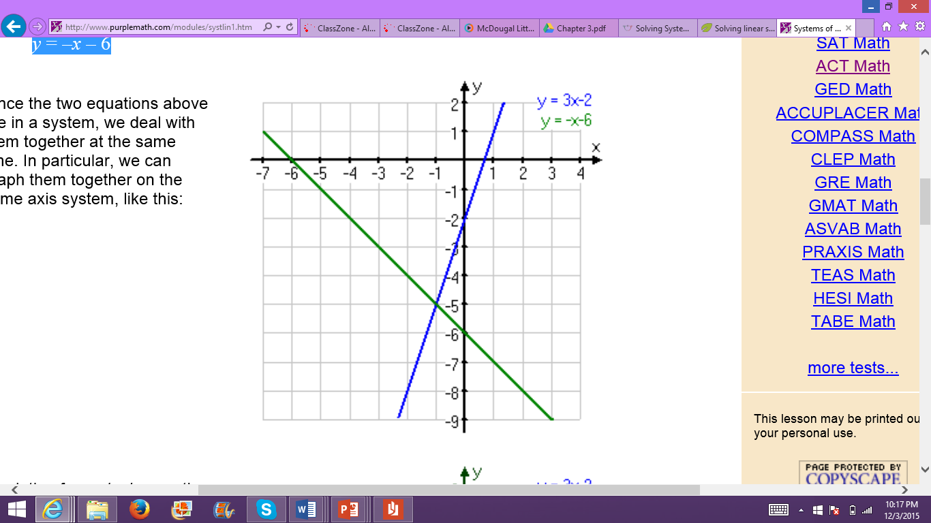

What did we say earlier the solution was to the two equations? Right (-1, -5). Where is (-1, -5) located on this graph? It’s the intersection of the two lines! Right!

Now we know the solution to linear systems of equations is the intersection point of all the lines in the system.

That is what we will be doing today, solving linear systems of equations by graphing!

* After the intro lecture, there will be an in-class activity. There are ten cards labeled 1 through 10 on each of them. Each card has two equations of lines on them. Each card will be taped to the wall, and cards will be hung all around the room.
  + I will explain the directions to the class, as I pass out the paper with the graphs on them for the activity.
  + Directions: Students will start at one station. They will have approximately three to five minutes at each station, and at the end of the time the students will go to the next numbered station. At each station, the students are to graph the equations of the lines that are on their paper, they need to find the intersection point, and write it down the coordinate point on the appropriate spot on their paper. They can turn in their papers to their period trey as they leave the classroom.
    - The goal is to make it to all ten stations. Problems at each station would be similar to these problems.

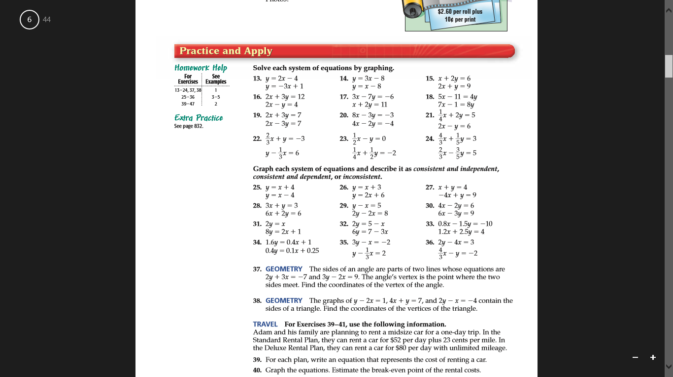

* + - If the students do not make it to all of the ten stations, then they can just turn in the stations they completed and they will not be penalized.
  + If there are no questions, then we can start the activity. Have the students number themselves off from 1 to 10. The number they called is the number of the station they will start at.
* As they leave the classroom, and turn in their paper from the in-class activity, they also must pick up a sheet of paper by the trey. The sheet of paper lists the problems from the textbook for their homework for the day.

**Assessment:**

* As a formative assessment the students will turn in their sheets of paper with the graphs and the solutions for all ten cards from the in-class activity.
* As another formative assessment, the students will turn in the following day the assigned homework problems from their textbook.
* As a formal assessment, students will have a traditional quiz on day five of the unit and a traditional test on day ten at the end of the unit.

**Reflection:**

* After I would do this lesson I would sit down at the end of the day and write my reflection for the lesson. I would ask myself these questions:
* What did I do well?
* If I were to teach this lesson again, what would I keep the same?
* If I were to teach this lesson again, what would I change?

Name: ____________________________________ 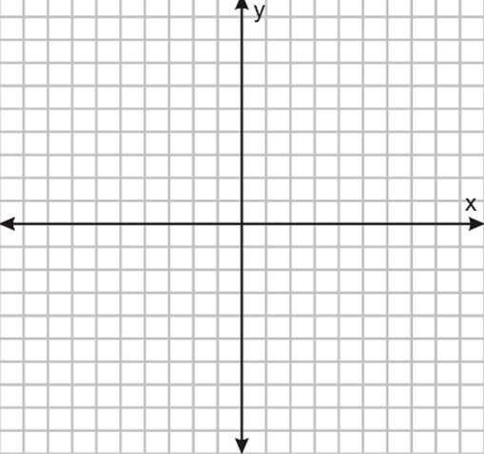

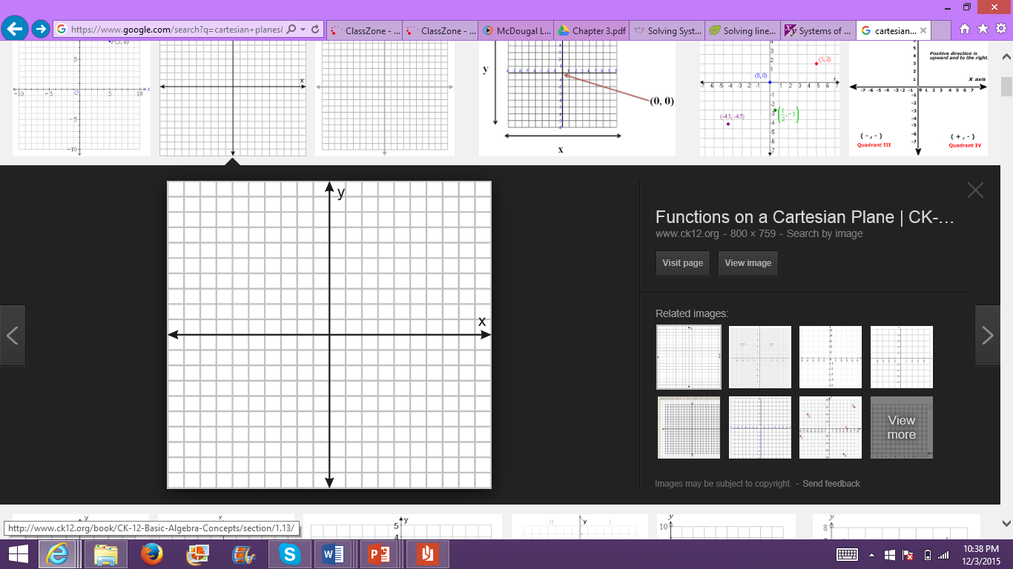

1. Solution: ( , ) 2. Solution: ( , )

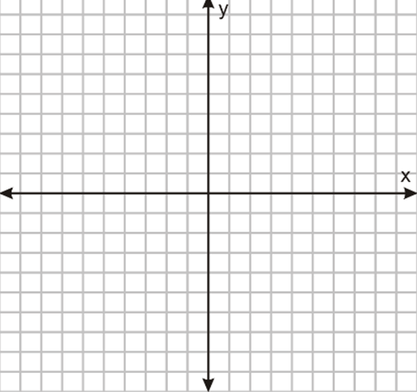



3. Solution: ( , ) 4. Solution: ( , )

Name: ____________________________________ 



5. Solution: ( , ) 6. Solution: ( , )





7. Solution: ( , ) 8. Solution: ( , )

Name: ____________________________________ 



9. Solution: ( , ) 10. Solution: ( , )





9. Solution: ( , ) 10. Solution: ( , )

**University of Mary Division of Education**

**Lesson Plan Format**

Day 2 – Day 3: Solving Linear Systems Algebraically with Substitution and Elimination

**Grade Level:**

10th and 11th grade

**Subject(s) Area:**

Algebra II

**Materials Needed:**

* For the teacher:

White board, white board markers, and loose leaf paper for students who need paper for notes, extra pencils for students who need pencils

* For the students:

Notebooks, calculators (if they so choose to help with computations), and pencils

**Standards:**

The standards for this lesson are the North Dakota Mathematical Content Standards based on the Common Core State Standards for Mathematics:

* HS.AREI.6: Solve systems of linear equations exactly and approximately (e.g., with graphs), focusing on pairs of linear equations in two variables. Note: Methods for solution could include substitution, linear combination, graphing and matrices.

**Objectives:**

* *Prior knowledge is to know how to solve equations for say a variable y in terms of x. Other prior knowledge is to have a basic knowledge of arithmetic, such as to know how to add and subtract, and to recognize and work with fractions.*
* Students will be able to solve equations for a variable in terms of another variable.
* Students will be able to solve the system of equations by the method of substitution and elimination.
* Students will be able to realize that there is one solution, infinitely many solutions (in the case of parallel lines), and there may be no solutions. Students will also be able to identify extraneous solutions.

**Learning Activities:**

* Students walk into the classroom. As they walk in, they can turn in their homework in the trey for their correct period. They can go to their assigned seats.
* As the bell rings, students should be seated, and they should be getting out their notebooks to be ready to take some notes on the lecture.
* I will start the lecture by a stating a mini recap of the prior lesson.
  + I want the recap of the prior lesson to be a discussion among the students and me. So I will ask them to see if they had problems with homework. If there are questions we can talk them through together as a class. I do not necessarily want to do problems on the homework, rather I want to ask them if they were confused on any of the steps, or if they don’t understand why we do some of the steps. While the students are asking questions, I want to drive two points home for the recap portion of the lesson. The points are:
    - The solution to the system of equations is the intersection point.
    - There is no solution to a system of parallel lines.
  + Now we can start on the new lesson. I will transition by first asking, “Ok so after your assignment last night how many of you are sick of graphing lines?” I will see the show of hands, and then say, “Ok so we have other methods of solving systems of equations! Two methods we will learn today is the substitution method and the elimination method!”
  + Now write on the board:

(Everything written in blue is written on the board, and everything in black is not written on the board, it is said aloud)

Substitution Method

Does anyone remember from Algebra I how to solve an equation for a variable in terms of another variable? Of course you know how! It is exactly what we do for when we solve an equation for y in terms of x, so we can graph the equation or the line!

Let’s start with two equations:

11 + y = 6x

-2x – 3y = -7 With the substitution method we will have five steps to help us

Step 1: Solve one equation for one variable

Let’s solve for y in the first equation

y = 6x – 11

and we still have the equation

-2x – 3y = -7

Step 2: Substitute

We need to substitute the equation we just solved for into the second equation, or we need to plug in 6x – 11 for y in the second equation.

-2x – 3(6x – 11) = -7

Step 3: Solve this new equation for the variable

Now we just solve for x like we how we usually do.

-2x – 18x + 33 = -7

-20x + 33 = -7

-20x = -40

x = 2

Step 4: Plug in to find the other variable

Now that we know x=2 we should plug 2 in for x in the **first** equation to find y.

11 + y = 6(2)

11 + y = 12

y = 1

You might think we are done now, but we just have one step left!

**NOTE:** If there is not enough time in class to finish the elimination method examples, we can do some more examples at the beginning of class next class period because day 2 and day 3 of this unit are both spent on this lesson topic. 🡪

Step 5: Check your answer

We got x = 2 and y = 1, but we need to make sure that the point (2, 1) works for both equations.

11 + (1) = 6(2) 🡪 12 = 12 CHECK!

-2(2) – 3(1) = -7 🡪 -7 = -7 CHECK!

Since the point (2, 1) satisfies both equations, then our answer and our solution to the system of equations is x = 2 and y = 1.

If you check your answer and the values for your variables so not satisfy at least one of the equations, then the solution is extraneous (meaning the solution does not exist). To be accurate, please write extraneous solution on problems like this.

Here is another practice problem I want you to do. When you are finished, you can consult your classmates to check each other’s work.

Ex.

2x = 8y – 10

6y = 3x – 15 Answer is x = 15 and y = 5.

Now we are going to learn another method called elimination!

Elimination Method

The goal of this method (other than finding the solution to the system of the equations) is to eliminate one variable in order to solve for the second variable. So we will have steps for this method too.

Step 1: Eliminate one of the variables

Let’s look at two equations to start.

3x + 4y = 2.5

5x – 4y = 25.5

Last time we eliminated one variable by substituting it into the other equation. This time we are going to try to eliminate one variable by adding the two equations together. So we know that we can add something to an equation as long as we are adding the same thing to both sides of the equation. Well in this particular example we know 5x – 4y = 25.5, since they are equal that is the same thing as saying 25.5 is the same as 5x – 4y. So we can eliminate one variable by adding the second equation to the first equation, by adding the left side of the first equation to the left side of the second equation, and by adding the right side of the first equation to the right side of the second equation. Let’s try it to see what happens!

3x + 4y = 2.5

+ 5x – 4y = + 25.5

8x + 0y = 28.0

Would you look at that! The y variable was eliminated! Why was it eliminated though? Well let’s look at the coefficients of both y terms, the coefficients were 4 and -4. What happens when you add 4 and -4? Right you get 0! These two equations were nice because they were already in a form that had opposite coefficients for the y variable. That does not always happen. (we will try another example when the coefficients do not work as nice.) But back to our problem.

Step 2: Solve for the remaining variable

So solve for x.

8x = 28

x = 3.5

Step 3: Plug in x to one of the equations to solve for y

Since x = 3.5, plug in 3.5 for x in either the first or second equation. It doesn’t matter which. I’m going to plug in 3.5 for x in the first equation.

3(3.5) + 4y = 2.5

10.5 + 4y = 2.5

4y = -8

y = -2

Step 4: Check you answer

Check your answers just like we did for the substitution method.

3(3.5) + 4(-2) = 2.5 🡪 10.5 + -8 = 2.5 🡪 2.5 = 2.5 CHECK!

5(3.5) – 4(-2) = 25.5 🡪 17.5 + 8 = 25.5 🡪 25.5 = 25.5 CHECK!

Let’s look at another example together, like I promised.

Ex.

3x – 7y = 10

6x – 8y = 8

Step 1: Eliminate one of the variables

In order to eliminate one of the variables, we need to have the coefficients of either the x term or the y term to have the same number coefficient and different sign. (Just like how the last problem was 4 and -4.) How are we going to do that for this example? Ok so first of all what variable do you want to try x or y? X sounds good to me. So the coefficients of both x terms are 3 and 6. What can we do to make them the same number? We can multiply 3*2 to get 6 right! But do I want both coefficients to be 6? No we need one of them to be negative to that they can cancel. So let’s just multiply 3 by -2 to get -6. Remember that we must multiply everything in the first equation by -2 (not just the x term by -2). So let’s do that

-2(3x – 7y = 10)

-6x +14y = -20 Now we add this to the second equation.

+6x – 8y = + 8

6y = -12

Step 2: Solve for the remaining variable

6y = -12

y = -2

Step 3: Plug in y to one of the equations to solve for x

3x – 7(-2) = 10

3x + 14 = 10

3x = -4

x = $\frac{-4}{3}$

Step 4: Check you answer

3($\frac{-4}{3}$) – 7(-2) = 10 🡪-4 + 10 = 14 🡪 10 = 10 CHECK!

6($\frac{-4}{3}$) – 8(-2) = 8 🡪 -8 + 16 = 8 🡪 8 = 8 CHECK!

* Most likely during these lectures we will either run out of class time or we will end with barely any time left in class.
  + If we run out of class time, we will continue were we left off the next day because the next day we will do more practice examples in class.
  + If we have time in class after this lecture, students can work on their assignment.
  + The assignment of homework problems from their book will be posted on the board. Since we will be covering this topic for two days in class, the homework is not due the next class period. The homework is due two class period from today.
* Students can leave the classroom once the bell has rung.

**Assessment:**

* As a formative assessment, the students will turn in their homework problems from their textbook two days after today’s lesson.
* As a formal assessment, students will have a traditional quiz on day five of the unit and a traditional test on day ten at the end of the unit.

**Reflection:**

* After I would do this lesson I would sit down at the end of the day and write my reflection for the lesson. I would ask myself these questions:
* What did I do well?
* If I were to teach this lesson again, what would I keep the same?
* If I were to teach this lesson again, what would I change?

**University of Mary Division of Education**

**Lesson Plan Format**

Day 2 – Day 3: Solving Linear Systems Algebraically with Substitution and Elimination

**Grade Level:**

10th and 11th grade

**Subject(s) Area:**

Algebra II

**Materials Needed:**

* For the teacher:

White board, white board markers, loose leaf paper the in-class math relay activity, and extra pencils for students who need pencils

* For the students:

Notebooks, calculators (if they so choose to help with computations), and pencils

**Standards:**

The standards for this lesson are the North Dakota Mathematical Content Standards based on the Common Core State Standards for Mathematics:

* HS.AREI.6: Solve systems of linear equations exactly and approximately (e.g., with graphs), focusing on pairs of linear equations in two variables. Note: Methods for solution could include substitution, linear combination, graphing and matrices.

**Objectives:**

* *Prior knowledge is to know how to solve equations for say a variable y in terms of x. Other prior knowledge is to have a basic knowledge of arithmetic, such as to know how to add and subtract, and to recognize and work with fractions.*
* Students will be able to solve equations for a variable in terms of another variable.
* Students will be able to solve the system of equations by the method of substitution and elimination.
* Students will be able to realize that there is a solution, infinitely many solutions (in the case of parallel lines), and there may be no solution. Students will also be able to identify extraneous solutions.
* Students will be able to evaluate each other’s work to see what their classmates are doing right and wrong, and students will be able to critique one another to help each other understand both methods.

**Learning Activities:**

* As students walk into to the class, they can go to their assigned seat, get their notebooks out, and wait patiently until the bell rings.
* If we did not finish the lecture portion of yesterday’s lesson, then we will finish the rest of the elimination method notes.
* After finishing the notes for the elimination method, we will start an in-class activity.
* Math relay in-class activity:
  + First, I will explain the directions. Each group of three students gets sheets of loose leaf paper. All the students must write their names on top of the loose leaf paper. The activity is math relay race. I will put a problem on the board, or a system of two linear equations on the main white board. I will also say whether the students have to solve by substitution, elimination, or I will say they can choose. One student will start the problem on the sheet of loose leaf paper by doing the first step, and then the pass the sheet of loose leaf to the person to their left, and that person will do the next step, and so forth. I recommend that the students have their notes out to know what steps they must do for each method. The first team to raise their sheet of loose leaf paper with correct solution on it wins five points. If a team raises their paper with an incorrect answer they receive zero points, and the next team to raise their paper with the correct answer receives three points. I will keep track of points on the board for each team. (I will number the teams for convenience.)
  + Before we move onto the next question, I want everyone to write their name by the step they did on the previous problem. I also want the students to rotate through for who starts each problem, so everyone has a chance to practice different steps of the methods.
  + I will have come to class with a list of names for each group of three students for the activity. I will list off the names for each team, and tell them where to sit in the classroom.
  + As we are playing the math relay game, after a problem if students have questions or are confused by any part of the solving process, we can address the confusions by going through the problem together.
  + Practice problems for the games are listed below. We do not need to go through all of these problems, I came up with more just in case the students go through them faster than I expect.

By substitution:

1. y = 3x – 4

y = 4 + x

2. 4c + 2d = 10

c + 3d = 10

3. a – b = 2

-2a + 3b = 3

4. x + y =

x – y = 2

By elimination:

5. 2r – 3s = 11

2r + 2s = 6

6. 2p + 4q = 18

3p – 6q = 3

7. 3g – 2h = -1

-12g + 8h = 5

8. 5m + n = 10

4m + n = 4

Problems where students can choose either method:

9. 3a – 2b = -3

3a + b = 3

10. f = 6 -2g

f + g = 1

11. 10m – 9n = 15

5m – 4n = 10

12. 0.25x + 1.75y = 1.25

0.5x + 2.5y = 2

* The math relay should take the entire class time. After the last problem, I will declare a winner, and the team can get a prize (something like cool gel pens, or cool pencils).
* As they leave the classroom, have someone from each group turn in the loose leaf sheets from the activity. Remind them to continue working on their homework from yesterday. Also remind them that it is due tomorrow!

**Assessment:**

* A formative assessment that the students will turn in at the end of the period will be the sheets of loose leaf paper from the math relay activity.
* In addition to the exit slip, another formative assessment is the students’ homework that they will turn in tomorrow. (The homework is the same homework assignment that was assigned yesterday.)
* As a formal assessment, students will have a traditional quiz on day five of the unit and a traditional test on day ten at the end of the unit.

**Reflection:**

* After I would do this lesson I would sit down at the end of the day and write my reflection for the lesson. I would ask myself these questions:
* What did I do well?
* If I were to teach this lesson again, what would I keep the same?
* If I were to teach this lesson again, what would I change?

**University of Mary Division of Education**

**Lesson Plan Format**

Day 4: Solving Systems of Linear Equations with three variables

**Grade Level:**

10th and 11th grade

**Subject(s) Area:**

Algebra II

**Materials Needed:**

* For the teacher:

White board, white board markers, loose leaf paper, and extra pencils for students who need pencils

* For the students:

Notebooks, calculators (if they so choose to help with computations), and pencils

**Standards:**

The standards for this lesson are the North Dakota Mathematical Content Standards based on the Common Core State Standards for Mathematics:

* HS.AREI.6: Solve systems of linear equations exactly and approximately (e.g., with graphs), focusing on pairs of linear equations in two variables. Note: Methods for solution could include substitution, linear combination, graphing and matrices.

**Objectives:**

* *Prior knowledge is to know how to solve equations with two unknown variables by method of elimination. Other prior knowledge is to have a basic knowledge of arithmetic, such as to know how to add and subtract, and to recognize and work with fractions.*
* Students will be able to solve equations for three unknown variables.
* Students will be able to solve the system of equations with three unknown variables by the methods of elimination.

**Learning Activities:**

* Students walk into the classroom. As they walk in, they can turn in their homework in the trey for their correct period. They can go to their assigned seats.
* As the bell rings, students should be seated, and they should be getting out their notebooks to be ready to take some notes on the lecture.
* Start with a refresher from what we did in the last two days of class.

“Everyone remembers how to solve by the method of elimination right? Great! Because today we are going to be using that method to solve for three equations with three unknown variables!”

* + Now write on the board:

(Everything written in blue is written on the board, and everything in black is not written on the board, it is said aloud)

Elimination Method with three unknowns

Now we are going to be looking at equations with x’s, y’s, and z’s. So while we work though our steps, let’s start with an example problem.

x + 2y + z = 10 E1

2x – y + 3z = -5 E2

2x – 3y – 5z = 27 E3

Step 1: Use elimination to create a system of two equations and two unknowns

Goal: at the end of the step we should have 2 equations with 2 unknown variables (like the ones we were working with the previous two days)

Let’s start with the first two equations E1 and E2

Ex + 2y + z = 10

2x – y + 3z = -5

What should we eliminate first? X? ok! WE can multiply by -2 on top sounds good

-2(x + 2y + z = 10)

-2x -4y -2z = -20

+ 2x – y + 3z = + -5

**-5y + z = -25** This is one of our two equations for this step!

Now we have to incorporate E3 into our problem. So we need E3 and another equation, either E1 or E2 to get our second equation with two unknowns. WE MUST MAKE SURE THAT WE NEED TO ELIMINATE THE SAME VARIABLE FOR ALL THREE EQUATIONS! Otherwise it does not work, we need to have only two unknown variables left at the end of this step.

Let’s do E2 and E3.

2x – y + 3z = -5

-(2x – 3y – 5z = 27) We still to eliminate x, so just subtract E3 from E2? sounds good to me!

2x – y + 3z = -5

-2x + 3y + 5z = -27

**2y + 8z = -32** This is the second equation for this step! We’ve reached our goal!

So our final two equations for this step are

-5y + z = -25

2y + 8z = -32

Step 2: Solve the new system of two equations (from Step 1)

-5y + z = -25

2y + 8z = -32 I’m going to multiply by -8 on the first equation

-8(-5y + z = -25)

40y – 8z = 200

+ 2y + 8z = + -32

42y = 168

y = 4

Now plug 4 back into one of the two equations from the beginning of this step and find z.

-5(4) + z = -25

-20 + z = -25

z = -5

Step 2: Solve the new system of two equations (from Step 1)

Step 3: Plug in two known values to find the last unknown value

Now we know y = 4 and z = -5, so we can find x by plugging in 4 and -5 back into of the three ORIGINAL equations (E1, E2, E3). I’m going to use the E1.

x + 2y + z = 10 E1

x + 2(4) + (-5) = 10

x + 8 – 5 = 10

x + 3 = 10

x = 7

Step 4: Check the answer

Now in order for x = 7, y = 4, and z = -5, these values have to satisfy all three original equations! Let’s check them.

x + 2y + z = 10 E1

2x – y + 3z = -5 E2

2x – 3y – 5z = 27 E3

(7) + 2(4) + (-5) = 10 🡪 7 + 8 – 5 = 10 🡪 10 = 10 CHECK!

2(7) – (4) + 3(-5) = -5 🡪 14 – 4 – 15 = -5 🡪 -5 = -5 CHECK!

2(7) – 3(4) – 5(-5) = 27 🡪 14 – 12 + 25 = 27 🡪 27 = 27 CHECK!

Our final solution is x = 7

y = 4

z = -5 Let’s do another example together!

Example 2:

x + y + z = 12 E1

6x – 2y – z = 16 E2

3x + 4y + 2z = 28 E3

Step 1: Use elimination to create a system of two equations and two unknowns

x + y + z = 12 E1

6x – 2y – z = 16 E2

2(E1) + E2

2(x + y + z = 12)

2x + 2y + 2z = 24

+ 6x – 2y –z = + 16

**8x + z = 40**

6x – 2y – z = 16 E2

3x + 4y + 2z = 28 E3

2(E2) + E3

12x – 4y – 2z = 32

+ 3x + 4y + 2z = + 28

15x = 60

**x = 4**

Since we eliminated both y and z variables in this step, we can plug x back into

8x + z = 40 to find z.

8x + z = 40

x = 4

8(4) + z = 40

32 + z = 40

z = 8

Step 3: Plug in two known values to find the last unknown value

x + y + z = 12 E1

(4) + y + 8 = 12

12 + y = 12

y = 0

Step 4: Check the answer

x + y + z = 12 E1

6x – 2y – z = 16 E2

3x + 4y + 2z = 28 E3

x = 4, y = 0, and z = 8

(4) + (0) + (8) = 12 🡪 12 = 12 Check

6(4) – 2(0) – (8) = 16 🡪 24 – 0 – 8 = 16 🡪 16 = 16 Check!

3(4) + 4(0) + 2(8) = 28 🡪 12 + 0 +16 = 28 🡪 28 = 28 Check!

* If there is time after the lecture, students can work on their homework assignment from their book. I want the student to work together on their homework problems.
  + As students are working on homework, walk around to make sure they are not simply cheating off each other, but actually helping each other.
  + Also make sure to walk around so that students can ask you questions if they are confused on a problem.
* If there is no time after lecture, students are dismissed and can go to their next class. Make sure they know what the homework assignment is for that day before they leave. ALSO MAKE SURE TO REMIND THEM THAT TOMORROW WILL BE A QUIZ ON THE LAST FOUR LESSONS (SOLVING SYSTEMS OF EQUATIONS.)

**Assessment:**

* As a formative assessment the students will turn in the following day the assigned homework problems from their textbook.
* As a formal assessment, students will have a traditional quiz on day five of the unit and a traditional test on day ten at the end of the unit.

**Reflection:**

* After I would do this lesson I would sit down at the end of the day and write my reflection for the lesson. I would ask myself these questions:
* What did I do well?
* If I were to teach this lesson again, what would I keep the same?
* If I were to teach this lesson again, what would I change?

**University of Mary Division of Education**

**Lesson Plan Format**

Day 5: Review and Quiz on Solving Systems of Equations

**Grade Level:**

10th and 11th grade

**Subject(s) Area:**

Algebra II

**Materials Needed:**

* For the teacher:

White board, white board markers, pencils for students who forgot their pencils, and quizzes for the students *(quiz and answer key is attached at the end of the lesson)*

* For the students:

Mini white boards and dry erase markers (provided by the teacher; one of each per student), paper towels (as erasers), calculators (if they so choose to help with computations), and pencils (not pens) for taking the quiz

**Standards:**

The standards for this lesson are the North Dakota Mathematical Content Standards based on the Common Core State Standards for Mathematics:

* HS.ACED.2: Create equations in two or more variables to represent relationships between quantities; graph equations on coordinate axes with labels and scales.
* HS.AREI.6: Solve systems of linear equations exactly and approximately (e.g., with graphs), focusing on pairs of linear equations in two variables. Note: Methods for solution could include substitution, linear combination, graphing and matrices.

**Objectives:**

* *Prior knowledge for this lesson consists of all the last four lessons. All the prior knowledge listed in the last four lessons is also prior knowledge for this lesson.*
* Students will be able to graph lines from examining linear equations.
* Students will be able to understand the intersection point is the solution to the linear system of equations.
* Students will be able to solve the system of equations by the method of substitution and elimination.
* Students will be able to realize that there is a solution, infinitely many solutions (in the case of parallel lines), and there may be no solution. Students will also be able to identify extraneous solutions.
* Students will be able to solve the system of equations with three unknown variables by the methods of elimination.

**Learning Activities:**

* Students walk into the classroom. As they walk in, they can turn in their homework in the trey for their correct period. As they walk to their assigned seats, they can grab a mini white board, a dry erase marker, and one paper towel.
* Students should be seated quietly before the bell rings.
* Once the bell has rung, I will explain to them that we will be reviewing for our quiz by doing a mini white board activity. They will take the quiz in the last 20 minutes of class. I will choose one student to hold me accountable for the time so they do get 20 minutes for the quiz.
* Mini white board activity:
  + I will write a problem on the board, and I may or may not write a specific method of how they should solve the problem. If there is a method written on the board, they must solve the system of equations by that particular method, whereas if I do not write a method on the board, they can choose whatever method they want.
  + When the students have their final answer, they should raise their white board. I will check everyone’s answers, and if more than half of the class got it wrong then I will go over the problem on the board.
* When there is twenty five minutes left of class, the student will remind me of the time. Half the students clean up their desk area. As I am passing out the quizzes, the students should pass their materials up to the front of their rows.
* Students will take the quiz.
  + For the students who get done early, they can work on other homework quietly.
  + If students do not finish, they must turn in their quizzes when the bell rings.
  + Students will turn the quizzes into me, and I will give them a slip of paper with their homework assignment on it. They are to watch Kahn academy videos to prepare them for the next class lesson. While they watch the video they must take notes, and the slip of paper explains the directions of how to take notes for these videos.

The websites are listed below:

1. <https://www.khanacademy.org/math/algebra2/alg2-matrices/basic-matrix-operations-alg2/v/introduction-to-the-matrix>
2. <https://www.khanacademy.org/math/algebra2/alg2-matrices/basic-matrix-operations-alg2/v/matrix-addition-and-subtraction-1>
3. <https://www.khanacademy.org/math/algebra2/alg2-matrices/basic-matrix-operations-alg2/v/scalar-multiplication>

* Once the bell rings, students are dismissed for their next class. Remind them to watch their videos!

**Assessment:**

* As a formal assessment, the students have taken a traditional quiz today.
* As another formal assessment, the students will have a traditional test on day ten at the end of the unit.

**Reflection:**

* After I would do this lesson I would sit down at the end of the day and write my reflection for the lesson. I would ask myself these questions:
* What did I do well?
* If I were to teach this lesson again, what would I keep the same?
* If I were to teach this lesson again, what would I change?

Quiz on Solving Systems of Equations Name: ______________________________

Directions: *Rewrite each equation in the form y = mx + b, graph the linear system (both lines) and write the solution as a coordinate point. Check the solution algebraically, and SHOW YOUR WORK. Please circle your final answer.*

**

1. 2x – y = 4

2x + 3y = 12

Directions: *Solve the linear system by either substitution method or elimination method. By the problem, write which method you chose. Make sure to check for extraneous solutions. SHOW ALL YOUR WORK.*

2. 2j – 3k = 3

3. 2c = 8 – d

6c + 3d = 12

j + k = 14

4. 0.4m + 1.8n = 8

1.2m + 3.4n = 16

5. 2r + 3s – 4t = 20

4r – s + 5t = 13

3r + 2s + 4t = 15

Quiz on Solving Systems of Equations Name: ______ANSWER KEY______

Directions: *Rewrite each equation in the form y = mx + b, graph the linear system (both lines) and write the solution as a coordinate point. Check the solution algebraically, and SHOW YOUR WORK. Please circle your final answer.*

**

1. 2x – y = 4

2x + 3y = 12

y = 2x – 4

y = $\frac{-2}{3}$ x + 4

2 = 2(3) – 4 🡪 2 = 6 – 4 🡪 2 = 2

2 = $\frac{-2}{3}$ (3) + 4 🡪 2 = -2 +4 🡪 2 = 2

Solution: (3, 2)

Directions: *Solve the linear system by either substitution method or elimination method. By the problem, write which method you chose. Make sure to check for extraneous solutions. SHOW ALL YOUR WORK.*

2. 2j – 3k = 3 SUBSTITUTION

3. 2c = 8 – d SUBSTITUTION

6c + 3d = 12 ELIMINATION

No solution; extraneous solution

j + k = 14 ELIMINATION

j = 9 and k = 5

4. 0.4m + 1.8n = 8 SUBSTITUTION

1.2m + 3.4n = 16 ELIMINATION

m = 2 and n = 4

5. 2r + 3s – 4t = 20 ELIMINATION

4r – s + 5t = 13

3r + 2s + 4t = 15

r = 5

s = 2

t = -1

**University of Mary Division of Education**

**Lesson Plan Format**

Day 6: Perform Simple Matrix Operations

**Grade Level:**

10th and 11th grade

**Subject(s) Area:**

Algebra II

**Materials Needed:**

* For the teacher:

Loose leaf paper for those students who need it, giant notecards with the matrices on them for the activity, small notecards with the correct and incorrect matrices on each, white board, white board markers, extra pencils for students, and extra calculators for students

* For the students:

Notebooks, pencils, and calculators (if they so choose to help with computations)

**Standards:**

The standards for this lesson are the North Dakota Mathematical Content Standards based on the Common Core State Standards for Mathematics:

* HS.NVM.8 (+): Add, subtract, and multiply matrices of appropriate dimensions.
* HS.NVM.11 (+): Multiply a vector (regarded as a matrix with one column) by a matrix of suitable dimensions to produce another vector. Understand a matrix as a transformation of vectors.

**Objectives:**

* *Prior knowledge is to know addition, subtraction, multiplication, and other simple mathematical calculations. Also prior knowledge is to be exposed to matrices and to know how to place data within a matrix. This lesson should be somewhat of a review from Algebra I.*
* Students will be able to add and subtract matrices.
* Students will be able to multiply a matrix by a scalar.
* Students will be able to perform combinations of simple matrix operations.

**Learning Activities:**

* Students walk into the classroom. As they walk in, they can go to their assigned seats.
* As the bell rings, students should be seated, and they should be getting out their notebooks for me to check their notes to see who watched the videos.
  + If students did not watch the video, they will be docked points from not taking the notes.
  + Students will also need to watch the videos tonight and take notes in addition to their homework assignment.
* After I check all their notes. I will break up the room into as even of groups as I can by counting them off. They can get together as groups, and then wait for the directions. We will be doing a game as an in class activity. I will call it the Matrix Maze.
* Matrix Maze:
  + Each team will start with a giant notecard with a matrix on it and with an operation on it. (Each team’s starting matrix is different.)
  + The team is supposed to do the operation on their matrix, whether that calculation be written down in their notebook, or on loose leaf sheets of paper that I will provide.
  + There will be small notecards, with a matrix and new operation on each notecard, scattered and hidden all throughout my classroom. Some notecards will be easy to find, and others may be more difficult. Once they find the new matrix the created from the operation, they must find the notecard with the same matrix on it.
  + Each team will continue in this process for seven operations on their starting matrix.
  + The first team to find the final notecard with the correct matrix on it wins! They will know it is the final notecard because it will be written in red. (There will be incorrect notecards scattered throughout the room as well including incorrect matrices written in red.)
  + Winners receive a small prize of cool pencils, or other gifts from a dollar store.
* The Matrix Maze should take the whole class period. While the students are playing the game, help the students refresh the students who forgot to watch the video on their matrix operation skills.
* Before the leave for their next period make sure they have all noted down somewhere on paper the homework assignment that is posted on the white board.
* Once the game is over, and once everyone has jotted down the homework assignment, dismiss the students to go to their next class.

**Assessment:**

* As a formative assessment, the students will have homework problems from their textbook.
* As a formal assessment, students will have a traditional quiz on day five of the unit and a traditional test on day ten at the end of the unit.

**Reflection:**

* After I would do this lesson I would sit down at the end of the day and write my reflection for the lesson. I would ask myself these questions:
* What did I do well?
* If I were to teach this lesson again, what would I keep the same?
* If I were to teach this lesson again, what would I change?

**University of Mary Division of Education**

**Lesson Plan Format**

Day 7: Evaluate Determinants and Matrix Multiplication

**Grade Level:**

10th and 11th grade

**Subject(s) Area:**

Algebra II

**Materials Needed:**

* For the teacher:

Loose leaf paper for those students who need it, white board, white board markers, extra pencils for students, and extra calculators for students

* For the students:

Notebooks, pencils, and calculators (if they so choose to help with computations)

**Standards:**

The standards for this lesson are the North Dakota Mathematical Content Standards based on the Common Core State Standards for Mathematics:

* HS.NVM.9 (+): Understand that, unlike multiplication of numbers, matrix multiplication for square matrices is not a commutative operation, but still satisfies the associative and distributive properties.

**Objectives:**

* *Prior knowledge is to know addition, subtraction, multiplication, and other simple mathematical calculations. Also prior knowledge is to be exposed to matrices and to know how to place data within a matrix. Prior knowledge also consists of the knowledge of the last lesson.*
* Students will be able to multiply matrices.
* Students will be able to find the determinant of a matrix.

**Learning Activities:**

* Students walk into the classroom. As they walk in, they can turn in their homework in the trey for their correct period. They can go to their assigned seats.
* As the bell rings, students should be seated, and they should be getting out their notebooks to be ready to take some notes on the lecture.
* Transition into lecture by saying, “Today we have two tasks! One – to be able to multiply matrices. Two – to find a determinant of a matrix! Let’s start with matrix multiplication.
  + Now write on the board:

(Everything written in blue is written on the board, and everything in black is not written on the board, it is said aloud)

Matrix Multiplication

Some people think we can multiply any matrix by any matrix, but actually there must be a specific dimension of the two matrices in order to be able to multiply them. You will see why as we go on. You can multiply matrices if and only if the number of columns in the first matrix is equal to the number of rows in the second matrix. Remember what a column and a row are? Remind me! Oh good, you guys remember. Remember our dimensions notation is row x column. So if [A] is an m x n matrix, then [A] has m rows and n columns. So if we multiply a matrix [A] and [B]

[A] 2 x 5 * [B] 5 x 4

can we multiply these? Yes we can because A has the same number of columns as B has rows, and that’s 5! What is even cooler is we know what size our product matrix will be. It will be a matrix that is a 2 x 4, because we cross out the 5’s.

[A] 2 x ~~5~~ * [B] ~~5~~ x 4 [AB] 2 x 4

So does this work?

[A] 1 x 3 * [B] 4 x 3

No, because 3 is not 4! Very good.

Ok so let’s start with an example.

Let R = [ $\begin{matrix}2 & -1 \\ 3 & 4\end{matrix}$] and S= [$\begin{matrix}3 & -9 \\ 5 & 7\end{matrix}$]

So RS = [ $\begin{matrix}2 & -1 \\ 3 & 4\end{matrix}$]*[$\begin{matrix}3 & -9 \\ 5 & 7\end{matrix}$]

Step 1: Multiply the numbers in the first row or R by the number in the first column of S, add the products, and put the result in the first row, first column of RS.

[ $\begin{matrix}2 & -1 \\ 3 & 4\end{matrix}$]*[$\begin{matrix}3 & -9 \\ 5 & 7\end{matrix}$] = [$\begin{matrix}2\left(3\right)+(-1)(5) & \\ & \end{matrix}$]

Step 2: Multiply the numbers in the first row of R by the numbers in the second column of S, add the products, and put the result in the first row, second column of RS.

[ $\begin{matrix}2 & -1 \\ 3 & 4\end{matrix}$]*[$\begin{matrix}3 & -9 \\ 5 & 7\end{matrix}$] = [$\begin{matrix}2\left(3\right)+(-1)(5) & 2\left(-9\right)+(-1)(7) \\ & \end{matrix}$]

Step 3: Multiply the numbers in the second row of R by the numbers of the first column of S, add the products, and put the result in the second row, first column of RS.

[ $\begin{matrix}2 & -1 \\ 3 & 4\end{matrix}$]*[$\begin{matrix}3 & -9 \\ 5 & 7\end{matrix}$] = [$\begin{matrix}2\left(3\right)+(-1)(5) & 2\left(-9\right)+(-1)(7) \\ 3\left(3\right)+4(5) & \end{matrix}$]

Step 4: Multiply the numbers in the second row of R by the numbers of the second column of S, add the products, and put the result in the second row, second column of RS.

[ $\begin{matrix}2 & -1 \\ 3 & 4\end{matrix}$]*[$\begin{matrix}3 & -9 \\ 5 & 7\end{matrix}$] = [$\begin{matrix}2\left(3\right)+(-1)(5) & 2\left(-9\right)+(-1)(7) \\ 3\left(3\right)+4(5) & 3\left(-9\right)+4(7)\end{matrix}$]

Step 5: Simplify the Matrix

RS = [$\begin{matrix}2\left(3\right)+(-1)(5) & 2\left(-9\right)+(-1)(7) \\ 3\left(3\right)+4(5) & 3\left(-9\right)+4(7)\end{matrix}$] = [$\begin{matrix}1 & -25 \\ 29 & 1\end{matrix}$]

If we have more time after the determinants, we can take a look at more examples today.

Finding the Determinant of a Matrix

Determinant – a value that helps us determine areas, when we don’t anything but the coordinates points of the shape

We write “determinant of matrix A” as detA

We are going to find the determinant of different sized matrices. The first note we need to make is that only square matrices have determinants. So only matrices that have the same number of rows as columns. First let’s try a 2x2 matrix. There is a formula for a 2x2 matrix.

A = [ $\begin{matrix}a & b \\ c & d\end{matrix}$] and detA = | | = ad – bc

Example:

A = [ $\begin{matrix}-2 & 5 \\ 6 & 8\end{matrix}$] and detA = | | = (-2)(8) – (5)(6) = -16 – 30 = -46

So detA = -46

Now we are going to find the determinant of anything bigger than a 2x2 matrix. There are different methods, but for our purposes we are going to use the diagonal method.

Determinants for anything bigger than 2x2

Let’s try a 3x3 matrix first

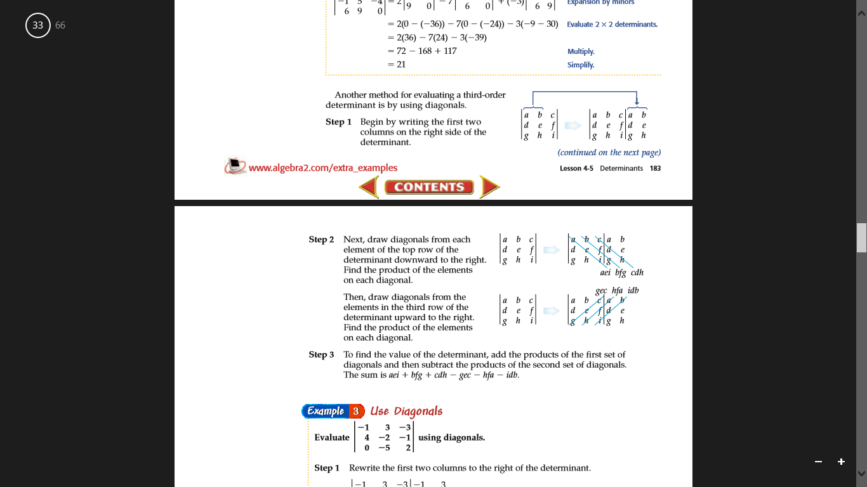

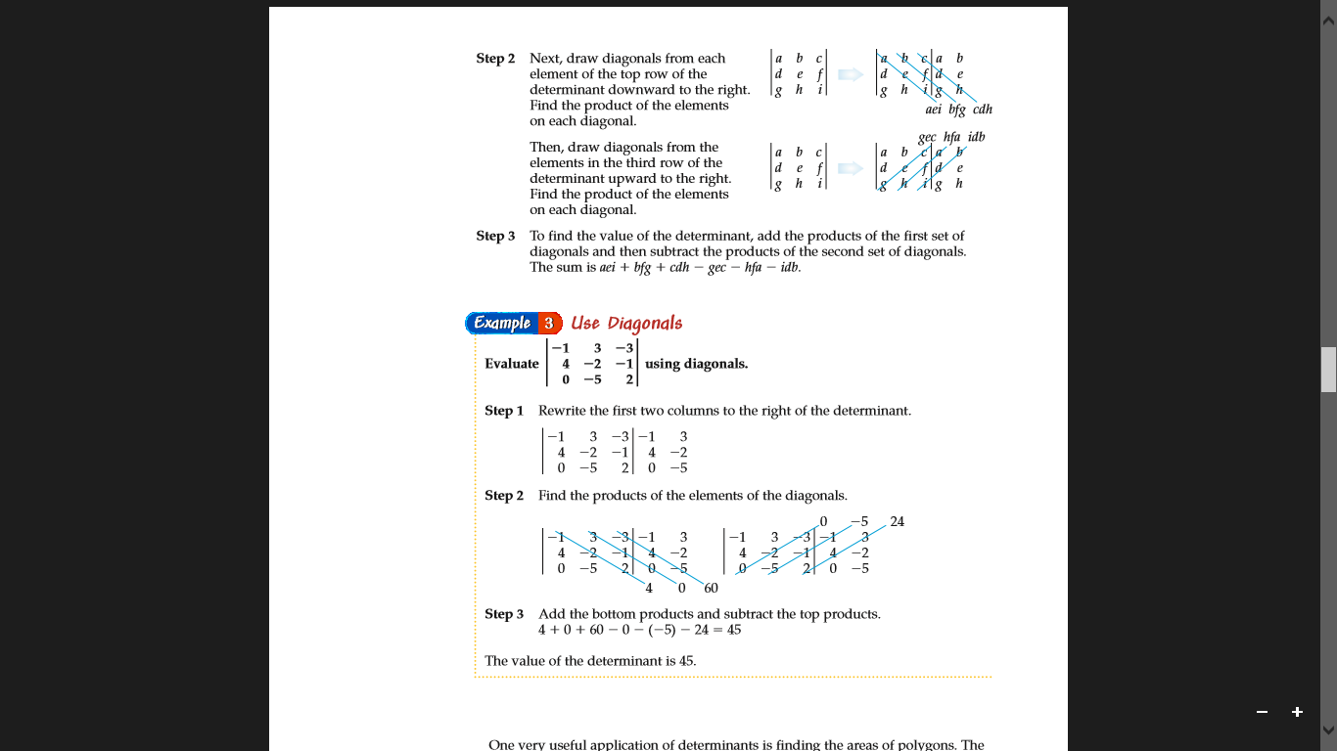

Let’s try an example!

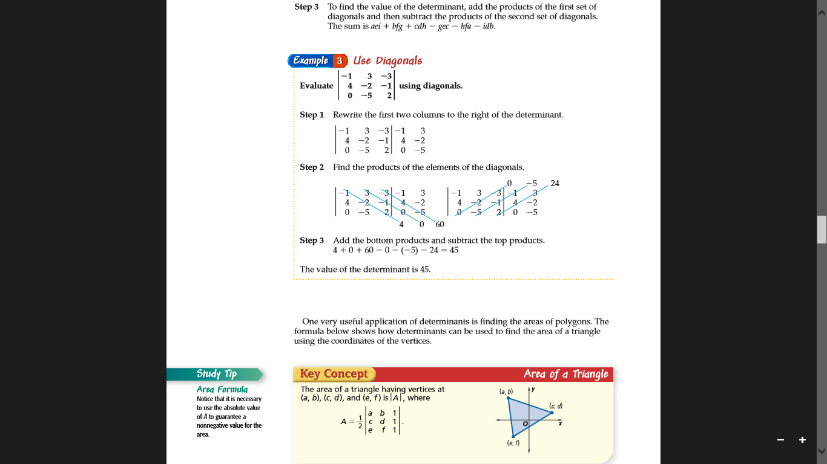

* After taking these notes, if there is still time left in class do more examples and answer questions students may have. If there is no time left, then just assign the homework and dismiss the students.
* Make sure all the students jot down the assigned homework before they leave.

**Assessment:**

* As a formative assessment, the students will have homework problems from their textbook.
* As a formal assessment, students will have a traditional quiz on day five of the unit and a traditional test on day ten at the end of the unit.

**Reflection:**

* After I would do this lesson I would sit down at the end of the day and write my reflection for the lesson. I would ask myself these questions:
* What did I do well?
* If I were to teach this lesson again, what would I keep the same?
* If I were to teach this lesson again, what would I change?

**University of Mary Division of Education**

**Lesson Plan Format**

Day 8: Use Inverse Matrices to Solve Linear Systems

**Grade Level:**

10th and 11th grade

**Subject(s) Area:**

Algebra II

**Materials Needed:**

* For the teacher:

Loose leaf paper for those students who need it, white board, white board markers, extra pencils for students, and extra calculators for students

* For the students:

Notebooks, pencils, and calculators (if they so choose to help with computations)

**Standards:**

The standards for this lesson are the North Dakota Mathematical Content Standards based on the Common Core State Standards for Mathematics:

* HS.AREI.8 (+): Represent a system of linear equations as a single matrix equation in a vector variable.

Example: Vector Variable $\left(\begin{aligned}x \\ y\end{aligned}\right)$.

Represent the system as a matrix equation: $\left\{\begin{aligned}2x+3y=0 \\ x+4y=8\end{aligned}\right\}$

Solution: [$\begin{matrix}2 & 3 \\ 1 & 4\end{matrix}$] [ $\begin{matrix}x \\ y\end{matrix}$] = [$\begin{matrix}0 \\ 8\end{matrix}$].

* HS.AREI.9 (+): Find the inverse of a matrix if it exists and use it to solve systems of linear equations (using technology for matrices of dimension 3 × 3 or greater).

**Objectives:**

* *Prior knowledge is to know addition, subtraction, multiplication, and other simple mathematical calculations. Also prior knowledge is to be exposed to matrices and to know how to place data within a matrix. Prior knowledge also consists of the knowledge of the last two lessons.*
* Students will be able to find the inverse of a matrix.
* Students will be able to solve systems of linear equations by using the inverse matrix.

**Learning Activities:**

* Students walk into the classroom. As they walk in, they can turn in their homework in the trey for their correct period. They can go to their assigned seats.
* As the bell rings, students should be seated, and they should be getting out their notebooks to be ready to take some notes on the lecture.
* Transition into lecture by saying, “These last couple of days we have been learning so much about matrices, and now today we finally get to put it together! We are going to use matrices to solve systems of equations!”
  + Now write on the board:

(Everything written in blue is written on the board, and everything in black is not written on the board, it is said aloud)

Writing systems of equations as a matrix equation

Before we can use matrices to solve systems of equations, we need to know how to write a system of eqautions as a matrix equation. So let’s look at this system of equations.

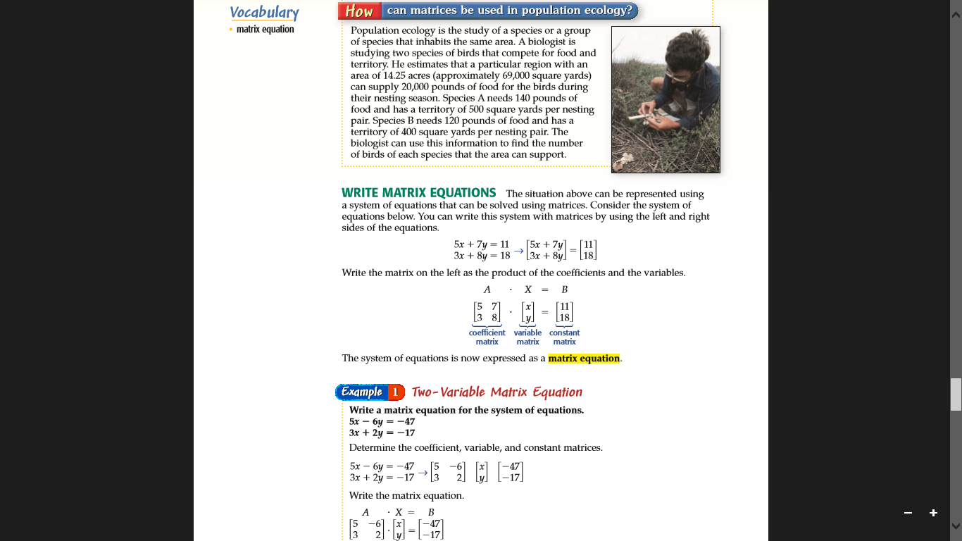

Let’s do another example:

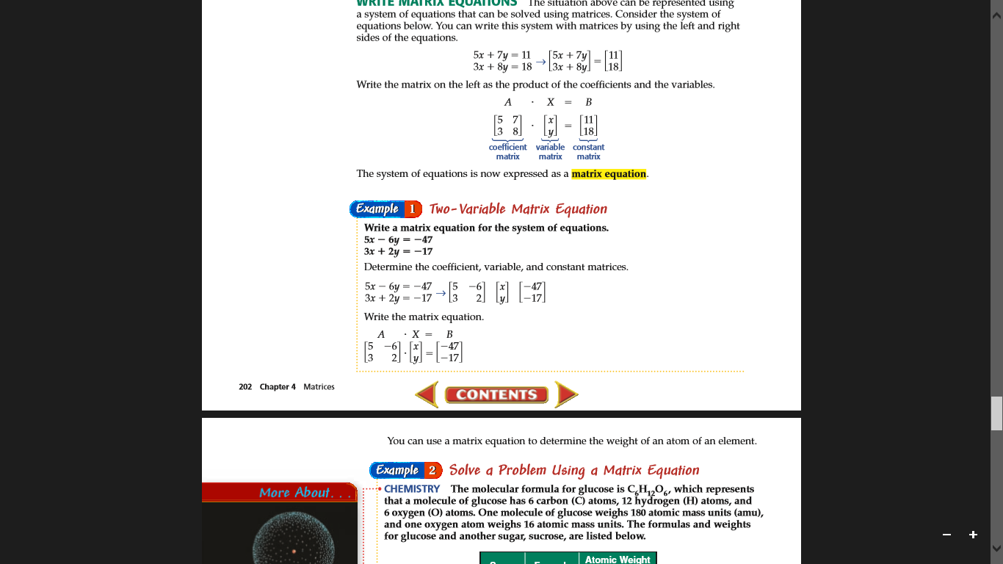

Inverse Matrix

First of all some matrices do not have an inverse. You can determine whether a matrix has an inverse by using the determinant.

So the inverse of matrix A = [ ] is A-1 = [ ], where ad – bc ≠ 0

Since the ad – bc is the value of detA. Therefore, if the value of the determinant of a matrix is 0, the matrix cannot have an inverse.

Let’s do an example:

Find the inverse of P.

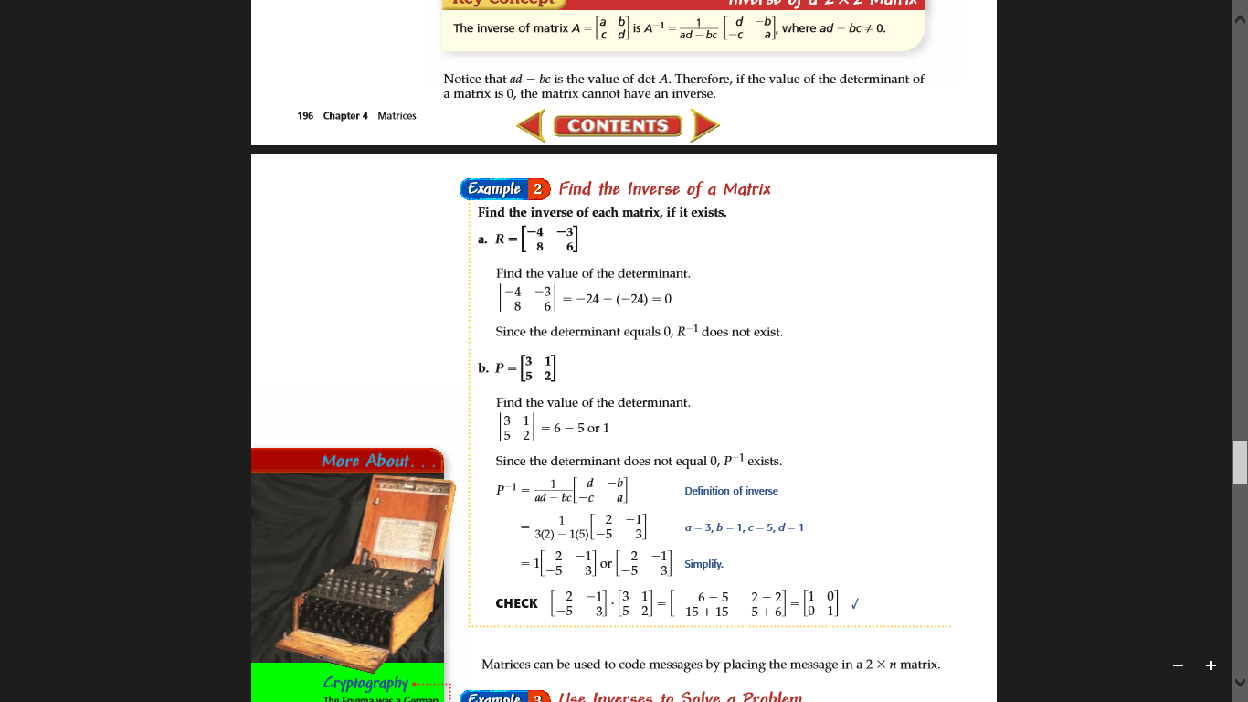

Answer: P-1 = [ ]

Solving a System of Equations by using inverse matrices

This is the moment we have been waiting for! We finally get to combine all our ideas to solve for the system!

Let’s start with an example:

6x + 2y = 11

3x – 8y = 1

First we have to rewrite this into a matrix equation.

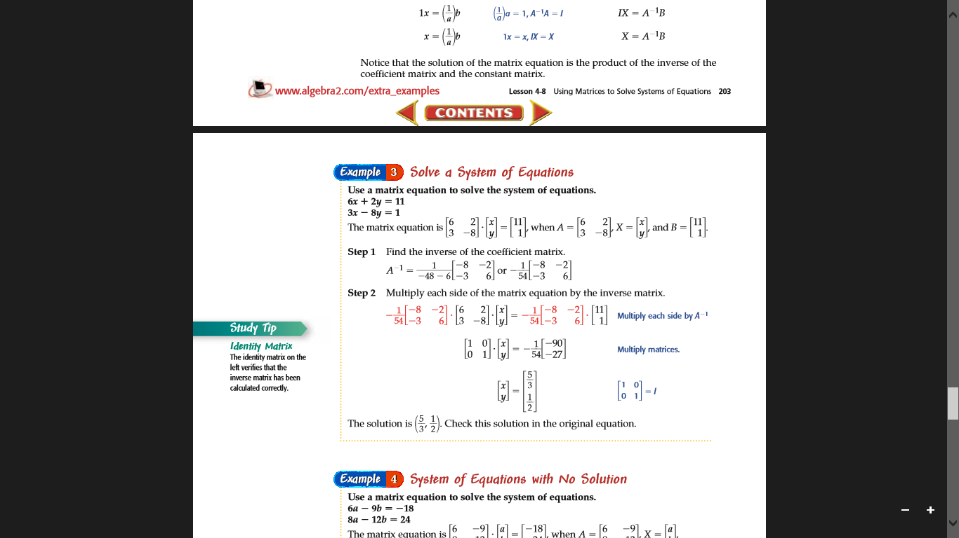

Now we need to find the inverse of A, or the coefficient matrix.



Now we want to solve for X or the matrix with x and y in it. We know from properties of algebra that A*A-1 = the identity. Since we found the inverse matrix of A let’s multiply both sides of our matrix equation by A-1. Remember order matters when we multiply matrices. So if we multiply A-1 like this

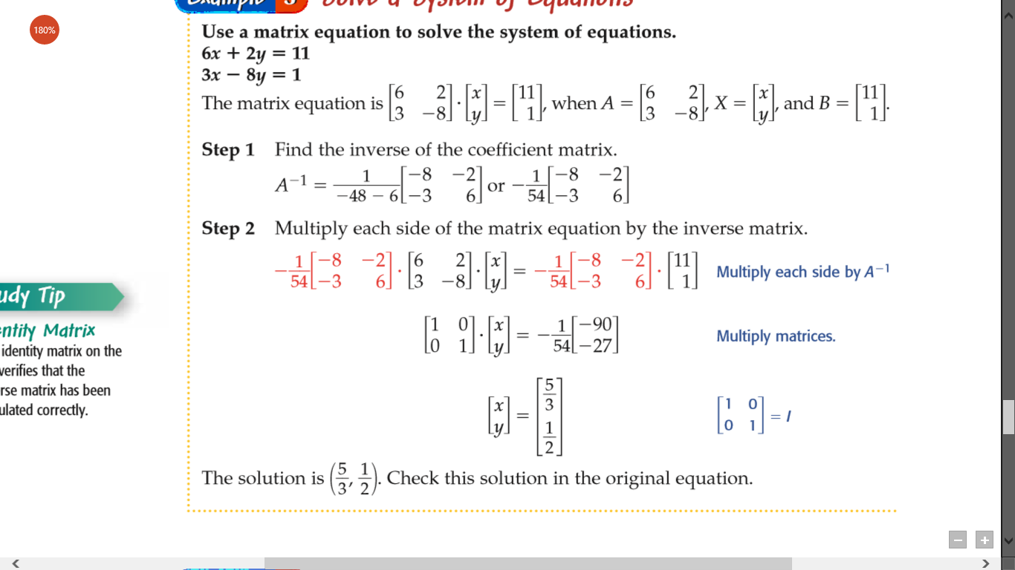, then we must multiply A-1 on the right hand side like this

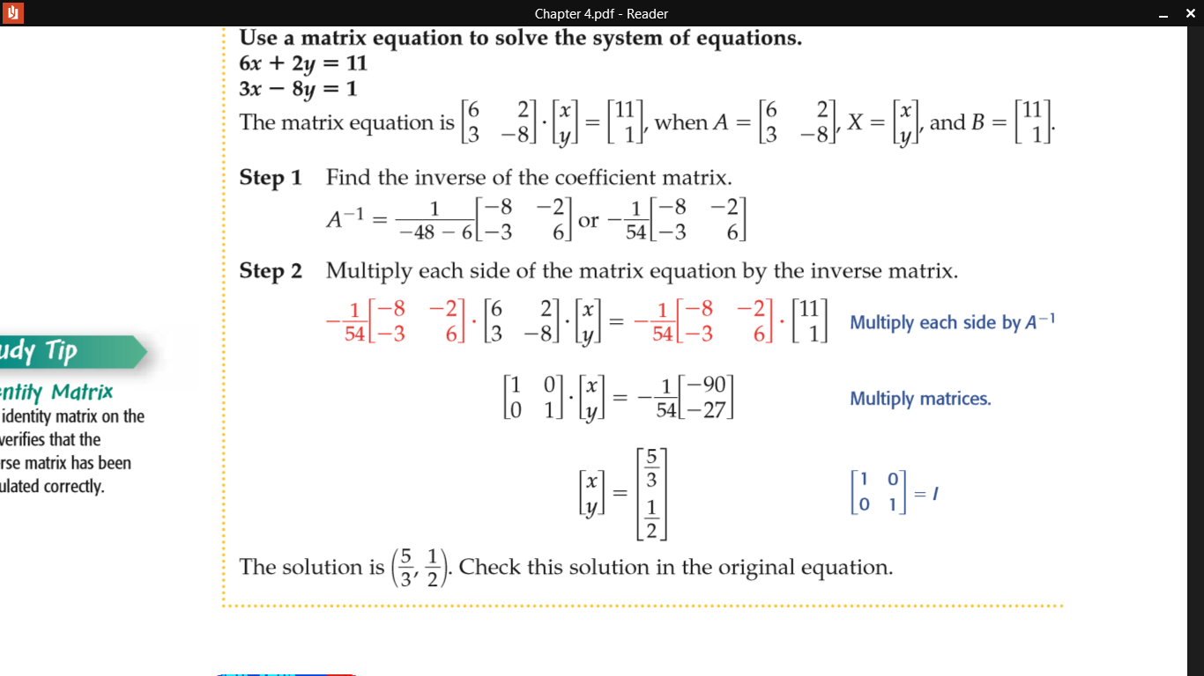 The whole equation should look like this:

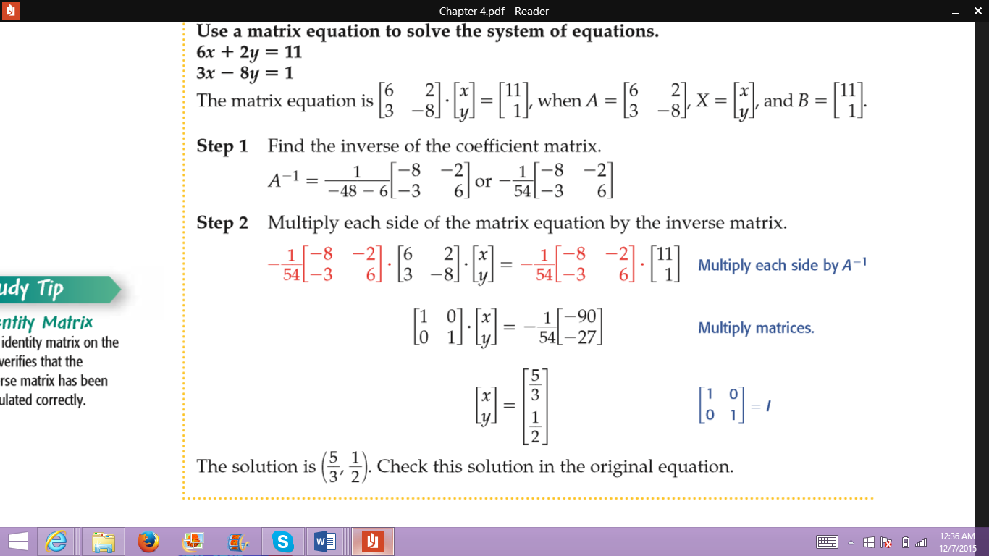

Now we just need to solve.

We know the left hand side turned into just [$\begin{matrix}x \\ y\end{matrix}$] and the right hand side we need to use our matirx multiplication knowledge to solve. To keep things simpler let’s keep the $\frac{-1}{54}$ out front for now.

So let’s calculate

= [$\begin{matrix}\left(-8\right)\left(11\right)+(-2)(1) \\ \left(-3\right)\left(11\right)+(6)(1)\end{matrix}$]= [$\begin{matrix}-90 \\ -27\end{matrix}$]

Now don’t forget about the $\frac{-1 }{54}$ out front, so take $\frac{-1}{54}$ [$\begin{matrix}-90 \\ -27\end{matrix}$] to get [$\begin{matrix}\frac{5}{3} \\ \frac{1}{2}\end{matrix}$] Remember this is all equal to the matrix with the variables x and y in it, so

[$\begin{matrix}x \\ y\end{matrix}$] = [$\begin{matrix}\frac{5}{3} \\ \frac{1}{2}\end{matrix}$], and x = $\frac{5}{3}$ and y = $\frac{1}{2}$

* After taking these notes, if there is still time left in class do more examples and answer questions students may have. If there is no time left, then just assign the homework and dismiss the students.
* Make sure all the students jot down the assigned homework before they leave.

**Assessment:**

* As a formative assessment, the students will have homework problems from their textbook.
* As a formal assessment, students will have a traditional quiz on day five of the unit and a traditional test on day ten at the end of the unit.

**Reflection:**

* After I would do this lesson I would sit down at the end of the day and write my reflection for the lesson. I would ask myself these questions:
* What did I do well?
* If I were to teach this lesson again, what would I keep the same?
* If I were to teach this lesson again, what would I change?

**University of Mary Division of Education**

**Lesson Plan Format**

Day 9: Review Day

**Grade Level:**

10th and 11th grade

**Subject(s) Area:**

Algebra II

**Materials Needed:**

* For the teacher:

Laptop, a projector device that connects to my laptop, white board, white board markers, loose leaf paper for students, extra pencils for students, and extra calculators for students

* For the students:

Smart phones, or any other device that receives internet, pencils, and calculators (if they so choose to help with computations)

**Standards:**

The standards for this lesson are the North Dakota Mathematical Content Standards based on the Common Core State Standards for Mathematics:

* HS.ACED.2: Create equations in two or more variables to represent relationships between quantities; graph equations on coordinate axes with labels and scales.
* HS.AREI.6: Solve systems of linear equations exactly and approximately (e.g., with graphs), focusing on pairs of linear equations in two variables. Note: Methods for solution could include substitution, linear combination, graphing and matrices.
* HS.NVM.8 (+): Add, subtract, and multiply matrices of appropriate dimensions.
* HS.AREI.8 (+): Represent a system of linear equations as a single matrix equation in a vector variable.

Example: Vector Variable.

Represent the system as a matrix equation:

Solution: [] [ ] = [].

* HS.NVM.9 (+): Understand that, unlike multiplication of numbers, matrix multiplication for square matrices is not a commutative operation, but still satisfies the associative and distributive properties.
* HS.AREI.9 (+): Find the inverse of a matrix if it exists and use it to solve systems of linear equations (using technology for matrices of dimension 3 × 3 or greater).
* HS.NVM.11 (+): Multiply a vector (regarded as a matrix with one column) by a matrix of suitable dimensions to produce another vector. Understand a matrix as a transformation of vectors.

**Objectives:**

* *Prior knowledge for this lesson consists of all the last eight lessons. All the prior knowledge listed in the last eight lessons is also prior knowledge for this lesson.*
* Students will be able to graph lines from examining linear equations.
* Students will be able to understand the intersection point is the solution to the linear system of equations.
* Students will be able to solve the system of equations by the method of substitution and elimination.
* Students will be able to realize that there is a solution, infinitely many solutions (in the case of parallel lines), and there may be no solution. Students will also be able to identify extraneous solutions.
* Students will be able to solve the system of equations with three unknown variables by the methods of elimination.
* Students will be able to add and subtract matrices.
* Students will be able to multiply a matrix by a scalar.
* Students will be able to perform combinations of simple matrix operations.
* Students will be able to multiply matrices.
* Students will be able to find the determinant of a matrix.
* Students will be able to find the inverse of a matrix.
* Students will be able to solve systems of linear equations by using the inverse matrix.

**Learning Activities:**

* Students walk into the classroom. As they walk in, they can turn in their homework in the trey for their correct period. Before they quietly proceed to their assigned seats, students should grab some loose leaf sheets of paper off the counter by the period trey.
* As the bell rings, students should be seated, and they should be getting out their smart phones, tablets, or laptops to be ready to play a review game of kahoot.
* I will explain how kahoot works, and it will most likely be review for the ones who have played before. I want them to not only answer the questions on their electronic devices, but I want them to write down work for every problem, so they can turn it in at the end of the period for points. If they do not finish the problem, that is ok! On the sheet of loose leaf paper, I want them to write their name at the top. Also on the paper, I want them to write down the according number to each problem, and then of course their work for each problem.
* We will play the kahoot game for the entire period. During the game, if most students got one particular question wrong, I want a student who got the answer right to come up to the board to do the problem. Not only do I want them to show the class, but I want them to explain to the class the process of how they are solving the problem. Make sure almost all students get to the board during the game.
* At the end of the period, students can turn in their loose leaf sheets of paper into the period trey as they leave the classroom.
* I will give the students two to five minutes to get packed up and turn in their work, and then I will dismiss them for the next class.

**Assessment:**

* As an informal assessment, the students turned in their work on the loose leaf paper from the kahoot game.
* As a formal assessment, the students will have a traditional test tomorrow because it is the end of the unit.

**Reflection:**

* After I would do this lesson I would sit down at the end of the day and write my reflection for the lesson. I would ask myself these questions:
* What did I do well?
* If I were to teach this lesson again, what would I keep the same?
* If I were to teach this lesson again, what would I change?

**University of Mary Division of Education**

**Lesson Plan Format**

Day 10: Test on Linear Systems and Matrices

**Grade Level:**

10th and 11th grade

**Subject(s) Area:**

Algebra II

**Materials Needed:**

* For the teacher:

The unit test *(test and answer key is attached at the end of this lesson)*, extra pencils for students, and extra calculators for students

* For the students:

Pencils, and calculators (if they so choose to help with computations)

**Standards:**

The standards for this lesson are the North Dakota Mathematical Content Standards based on the Common Core State Standards for Mathematics:

* HS.ACED.2: Create equations in two or more variables to represent relationships between quantities; graph equations on coordinate axes with labels and scales.
* HS.AREI.6: Solve systems of linear equations exactly and approximately (e.g., with graphs), focusing on pairs of linear equations in two variables. Note: Methods for solution could include substitution, linear combination, graphing and matrices.
* HS.NVM.8 (+): Add, subtract, and multiply matrices of appropriate dimensions.
* HS.AREI.8 (+): Represent a system of linear equations as a single matrix equation in a vector variable.

Example: Vector Variable.

Represent the system as a matrix equation:

Solution: [] [ ] = [].

* HS.NVM.9 (+): Understand that, unlike multiplication of numbers, matrix multiplication for square matrices is not a commutative operation, but still satisfies the associative and distributive properties.
* HS.AREI.9 (+): Find the inverse of a matrix if it exists and use it to solve systems of linear equations (using technology for matrices of dimension 3 × 3 or greater).
* HS.NVM.11 (+): Multiply a vector (regarded as a matrix with one column) by a matrix of suitable dimensions to produce another vector. Understand a matrix as a transformation of vectors.

**Objectives:**

* *Prior knowledge for this lesson consists of all the last nine lessons. All the prior knowledge listed in the last nine lessons is also prior knowledge for this lesson.*
* Students will be able to graph lines from examining linear equations.
* Students will be able to understand the intersection point is the solution to the linear system of equations.
* Students will be able to solve the system of equations by the method of substitution and elimination.
* Students will be able to realize that there is a solution, infinitely many solutions (in the case of parallel lines), and there may be no solution. Students will also be able to identify extraneous solutions.
* Students will be able to solve the system of equations with three unknown variables by the methods of elimination.
* Students will be able to add and subtract matrices.
* Students will be able to multiply a matrix by a scalar.
* Students will be able to perform combinations of simple matrix operations.
* Students will be able to multiply matrices.
* Students will be able to find the determinant of a matrix.
* Students will be able to find the inverse of a matrix.
* Students will be able to solve systems of linear equations by using the inverse matrix.

**Learning Activities:**

* As students walk into the classroom, I will be handing the test to them. Once they get to their assigned seat they can start the test.
* Have written on the board.

Don’t forget to write your name on your test!

You are only allowed to write in pencil on the test.

You are allowed to use calculators on this test.

* As students are taking the test, walk around to see if anyone needs help. Check to make sure students are staying on task.
* Once the students are done they can turn the test in to me at my desk.
  + If the bell has not rung yet, students must return to their desk and work on other homework. If the student does not have any homework, they can choose to do a math puzzle from one of my shelves in the back part of the room.
  + If the bell has rung, students must turn in the test even if the test is uncompleted. Students are dismissed to their next class.

**Assessment:**

* This lesson is the formal assessment for the entire unit on Linear Systems and Matrices.

**Reflection:**

* After I would do this lesson I would sit down at the end of the day and write my reflection for the lesson. I would ask myself these questions:
* What did I do well?
* If I were to teach this lesson again, what would I keep the same?
* If I were to teach this lesson again, what would I change?

Algebra II Name: ______________________________

Unit 3 Test

Part I: Linear Systems

Graph the linear system (both lines) and estimate the solution by observing the graph. Then check the solution algebraically, and SHOW YOUR WORK. Circle your estimation, and box the correct solution.

1. 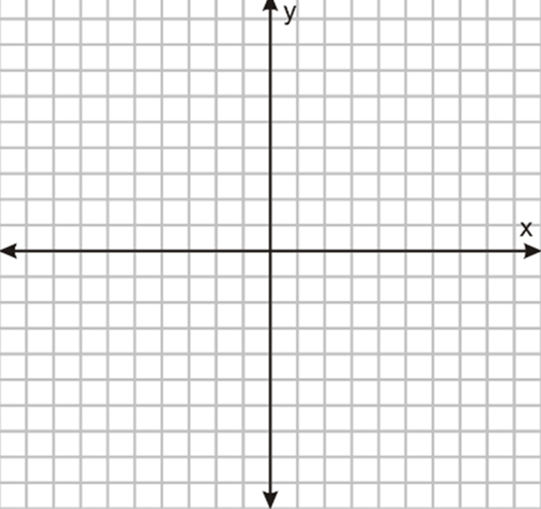4x + y = 5 and 3x – y = 2
2. 2x – 3y = 15 and x – $\frac{3}{2}$ y = -3

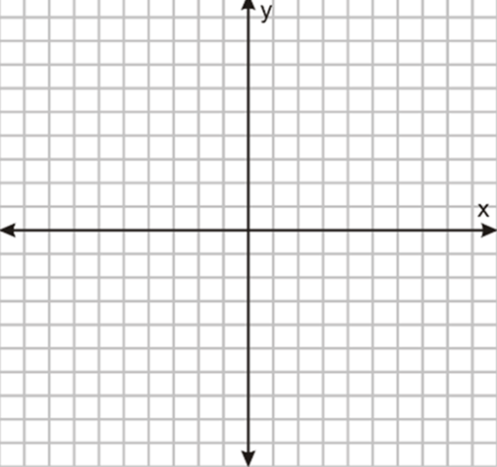

Solve the linear system by either substitution method or elimination method. Make sure you use the substitution method at least twice, and the rest you can use elimination. SHOW ALL WORK.

5. 2x +3y = -2

4x +7y = -6

7. 3x + 2y = 15

-x + 4y = -33

1. 3x + y = -9

x = -10 + 2y

6. x = -26 – 4y

-5x – 2y = -14

8. x – y + z = -3

2x – y + 5z = 4

4x + 2y – z = 2

Part II: Matrices

Use the given matrices to evaluate the expression for each problem, if possible. If it is not possible to solve the expression, state the reason why. SHOW ALL WORK.

**A=**[] **B=**[] **C=** [] **D=** [] **E=** []

10. A – 2D

12. AB

9. C – 2B

11. 4D – E

13. DE

Use the inverse matrix to solve the linear systems. SHOW ALL WORK.

14. 3x + 4y = 6

4x + 5y = 7

15. 2x – 7y = -36

x- 3y = -16

Algebra II Name: _____ANSWER KEY__________

Unit 3 Test

Part I: Linear Systems

Graph the linear system (both lines) and estimate the solution by observing the graph. Then check the solution algebraically, and SHOW YOUR WORK. Circle your estimation, and box the correct solution.

1. 4x + y = 5 and 3x – y = 2

4(1) + (1) = 5 🡪 4 +1 = 5 🡪 5 = 5

3(1) – 1 = 2 🡪 3 – 1 = 2 🡪 2 = 2

Solution: (1, 1)



1. 2x – 3y = 15 and x – $\frac{3}{2}$ y = -3

y = $\frac{2}{3}$ x – 5 and y = $\frac{2}{3}$ x + 2

No solution: parallel lines

Solve the linear system by either substitution method or elimination method. Make sure you use the substitution method at least twice, and the rest you can use elimination. By the problem, write which method you chose. Make sure to check for $extraneous$ solutions. SHOW ALL YOUR WORK.

5. 2x + 3y = -2

4x + 7y = -6 SUBSTITUTION

ELIMINATION

x = 2 and y = -2

7. 3x + 2y = 15

-x + 4y = -33 SUBSTITUTION

ELIMINATION

x = 9 and y = -6

1. 3x + y = -9

x = -10 + 2y SUBSTITUTION

ELIMINATION

x = -4 and y = -3

6. x = -26 – 4y

-5x – 2y = -14 SUBSTITUTION

ELIMINATION

x = 6 and y = -8

8. x – y + z = -3 ELIMINATION

2x – y + 5z = 4

4x + 2y – z = 2

x = -1, y = 4, and z = 2

Part II: Matrices

Use the given matrices to evaluate the expression for each problem, if possible. If it is not possible to solve the expression, state the reason why. SHOW ALL WORK.

**A=**[] **B=**[] **C=** [] **D=** [] **E=** []

10. A – 2D

Not possible. It is not possible because [A] is not the same size as [D]. [A] is a 2X2 and [D] is a 2X3.

12. AB

[]

9. C – 2B

[]

11. 4D – E

[]

13. DE

Not possible. It is not possible because [D] is

the same size as [E]. [D] and [E] are 2X3.

In order for matrix multiplication to work

the columns of the second matrix have to have

the same number of entries as do the rows of the

first matrix.

Use the inverse matrix to solve the linear systems. SHOW ALL WORK.

14. 3x + 4y = 6

4x + 5y = 7

x = -2 and y = 3

15. 2x – 7y = -36

x – 3y = -16

x = -4 and y = 4